**Charlottesville & Albemarle Area Community Wellbeing Profile**

UVA Center for Community Partnerships

in partnership with Albemarle County and the

City of Charlottesville

July 2025

Table of Contents

Executive Summary 1

Introduction 2

Demographic Profile 2

Race and Ethnicity 3

Language 4

Disability 6

Human Development Framework 7

The Human Development Index 7

AHDI in the Region 8

A Long and Healthy Life: Health Profile 9

Life Expectancy 9

Primary Care and Mental Health Care Providers 10

Health Insurance 12

Access to Parks and Exercise Opportunities 14

Access to Knowledge: Education Profile 15

Degree Attainment 15

School Enrollment 16

Child Care 17

Civil Society 18

Decent Standard of Living: Economic Security and Housing Profile 20

Earnings and Income 20

Where People Live and Work 21

Housing: Renters and Owners 23

Evictions 24

People Experiencing Homelessness 26

Bed Capacity Among Organizations Serving Unhoused Residents 29

Locality Profiles 31

Contributors 31

The UVA Center for Community Partnerships 32

Project Repository 32

Citation 32

Appendix 33

Data Sources by Figure/Table 33

## 

## Executive Summary

The Charlottesville and Albemarle Area Community Wellbeing Profile provides current and trend data for measures related to the well-being of the collective population, expanding on the individual locality profiles for the city and county. The American Human Development Index (AHDI)—calculated from metrics on health, access to knowledge, and living standards and scored on a scale from 0 to 10—is used as a framework to assess and advocate for increased and inclusive well-being. Metrics on the combined area of the city and county can highlight outcomes and support decisions that cross geographical boundaries.

The AHDI for both Charlottesville and Albemarle is higher than the state in large part due to the high degree of educational attainment among residents. The primary difference in AHDI is due to higher earnings reported in Albemarle relative to those in Charlottesville.

**American Human Development Index: Local and State-wide Comparison**

|  |  | Health | Access to Knowledge | | | | Living Standards |
| --- | --- | --- | --- | --- | --- | --- | --- |
| American HD Index | Life Expectancy (years) | At Least High School Diploma | At Least Bachelor’s Degree | Graduate Degree | School Enrollment | Median Earnings  (2023 $) |
| Charlottesville & Albemarle Combined | 7.0 | 81 | 94% | 61% | 31% | 86% | $48,041 |
| Albemarle | 7.3 | 82 | 94% | 61% | 31% | 85% | $51,922 |
| Charlottesville | 6.2 | 79 | 93% | 61% | 33% | 87% | $38,285 |
| Virginia | 5.8 | 78 | 91% | 41% | 18% | 76% | $49,405 |
| Data Sources: *Life Expectancy:* County Health Rankings, 2024. *Education and Earnings:* U.S. Census Bureau, American Community Survey 5-year estimates, 2023. | | | | | | | |

While the rate of residents lacking health insurance has declined, with 6% of residents overall without coverage, there are stark disparities by racial and ethnic identity, with 3% of white residents, 9% of Black residents, and 24% of Hispanic residents lacking coverage.

Educational attainment has increased in Charlottesville and Albemarle over time, with 61% of residents having a four-year college degree, up from 53% in 2018. Residents haven't benefited equally from this rise, with 26% of Black residents and 40% of Hispanic residents earning a bachelor’s degree or higher compared to 66% of white residents.

Median earnings rose steadily in the last decade. While economic opportunities grew, the housing capacity did not keep pace, and many city and county residents struggled to pay rent. More than half of all renters—nearly 12,800 households—were rent-burdened, spending over 30% of their income on housing, and local courts saw both eviction filings and judgments increase to pre-pandemic levels.

These and other measures and outcomes presented in the community profile are a resource for local residents and leaders to support understanding of our collective well-being and point to challenges we can address together.

## Introduction

The City of Charlottesville and Albemarle County are deeply intertwined—economically, socially, and environmentally. This interdependence extends to the well-being of all who live and work in either the city or the county. Some public challenges can only be addressed through cross-jurisdictional collaboration. Additionally, some resources are strengthened and bolstered through intentional collaboration. Multiple systems that structure lived experiences of residents—job markets, housing markets, health care infrastructure, and more—operate regionally. In addition to coordination across local governments, the combined Charlottesville-Albemarle region benefits from a rich web of civic organizations, service providers, and regional authorities.

This report expands on the separate Albemarle and Charlottesville Community Wellbeing Profiles done in partnership with Albemarle County and the City of Charlottesville. Like these locality-centered profiles, this Charlottesville-Albemarle area profile builds on the American Human Development Index as a framework to assess and advocate for increased and inclusive well-being. This report centers combined measures and introduces additional data on outcomes and issues that cross geographical boundaries.

Each section of the report—the Demographic Profile, Health Profile, Education Profile, and Economic Security and Housing Profile—provides measures representing the collective population of the City of Charlottesville and Albemarle County.[1] While the locality profiles break down measures by place and by race, the combined regional profile focuses on comparisons over time and by race. Information alone, though, is not a solution. These data are only starting points for the wider conversation and planning our community can undertake together.

## Demographic Profile

The people who live in Charlottesville and Albemarle represent the region’s primary assets. Residents bring a multitude of strengths, shape collective needs, and provide available resources to address those needs. Understanding who the community is composed of and how that composition is steadily evolving supports the creation of programs and use of resources that effectively invest in people. The profile begins by examining the population attributes of the estimated 169,533 residents of the city and county combined.[2]

The combined regional measures below focus on race and ethnicity, language and linguistic isolation, and the prevalence of disabilities among residents. These measures, along with data about age, sex, and nativity are also provided separately in the locality profiles. Advocacy is enhanced by bridging across jurisdictions to identify common needs and build coalitions.

### Race and Ethnicity

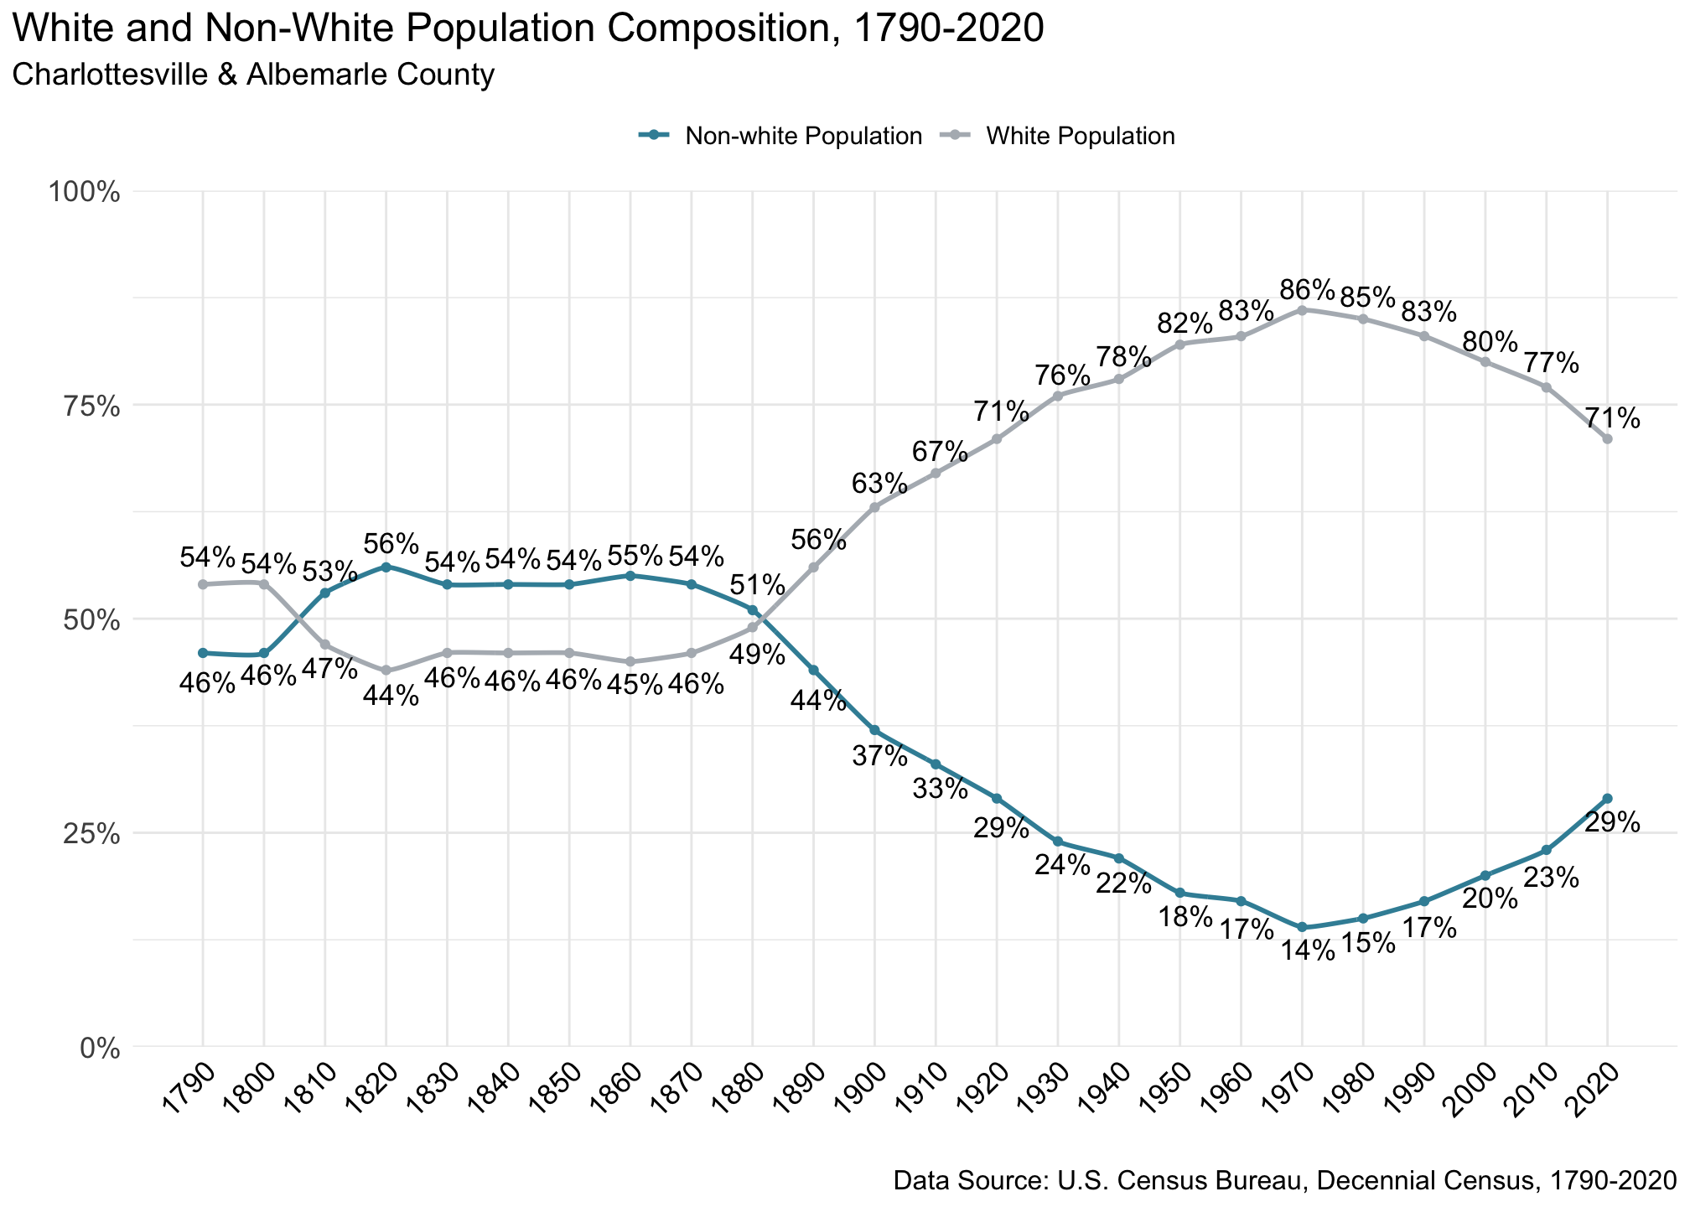

Figure 1.1: White and Non-White Population Composition, 1790-2020. Inherent limitations of and inconsistencies across historical census data collections require simplifying long-term population trends into ‘white’ and ‘nonwhite.’

African Americans, free and enslaved, constituted the majority of the region’s population during the height of chattel slavery prior to the American Civil War. Post-Civil war, the proportion of African Americans in the area rapidly declined. Black men and women migrated away from the region. This movement was driven by opportunities opening in the North, and lack of opportunities in the South. Since that time, the majority of the population of Charlottesville and Albemarle has identified themselves in the census as white (Figure 1.1).

Over the past decade, the racial and ethnic composition of Charlottesville and Albemarle has remained steady even as the population has grown. In 2013, with a combined population of 144,300, 12% of residents identified as Black, 5% of residents identified as Asian, 5% as Hispanic or Latino, 2% identified with multiple races, and the remaining 74% identified as white. In 2023, with a combined population of 160,000, the proportion of residents by race and ethnicity exhibited minimal shifts (Figure 1.2).

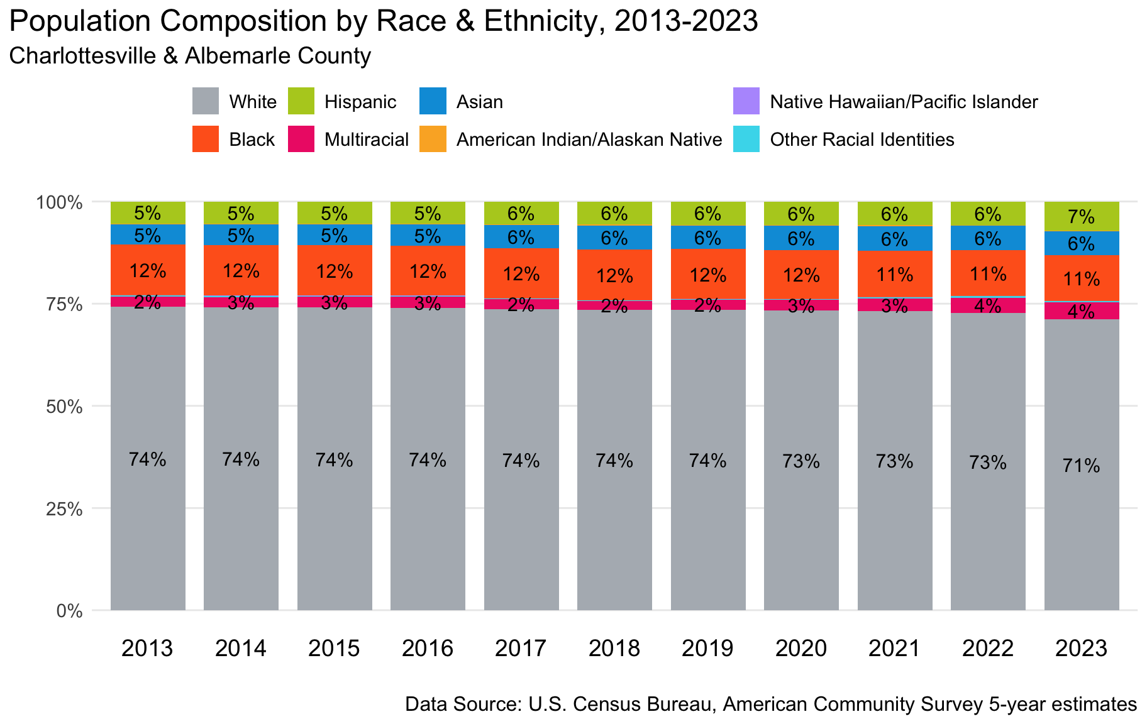

Figure 1.2: Population Composition by Race & Ethnicity, 2013-2023. According to US Census data, in 2023 71% of residents identified as White, 11% as Black or African American, 6% as Asian, 7% as Hispanic or Latino, and 4% as Multiracial. Less than 1% identified as American Indian/Alaskan Native, Native Hawaiian/Pacific Islander, or an other racial identity.

### Language

Linguistic isolation can greatly influence the accessibility of critical services for new residents. The U.S. Census Bureau defines linguistic isolation, or limited English speaking, as households where no one age 14 or older speaks English proficiently.[3]

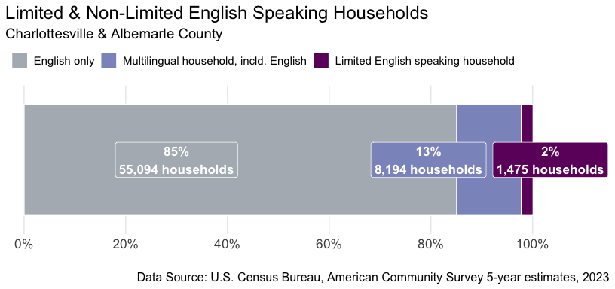

Figure 1.3: Limited & Non-Limited English Speaking Households, 2023. 85% of households speak only English, 13% of households are multilingual including English, and 2% are limited English speaking households.

Across Albemarle and Charlottesville, about 2% of households, or 1,475 households—each representing multiple residents—are linguistically isolated. Another 13%, or over 8,000 households, are multilingual, representing a rich cultural resource for the region (Figure 1.3).

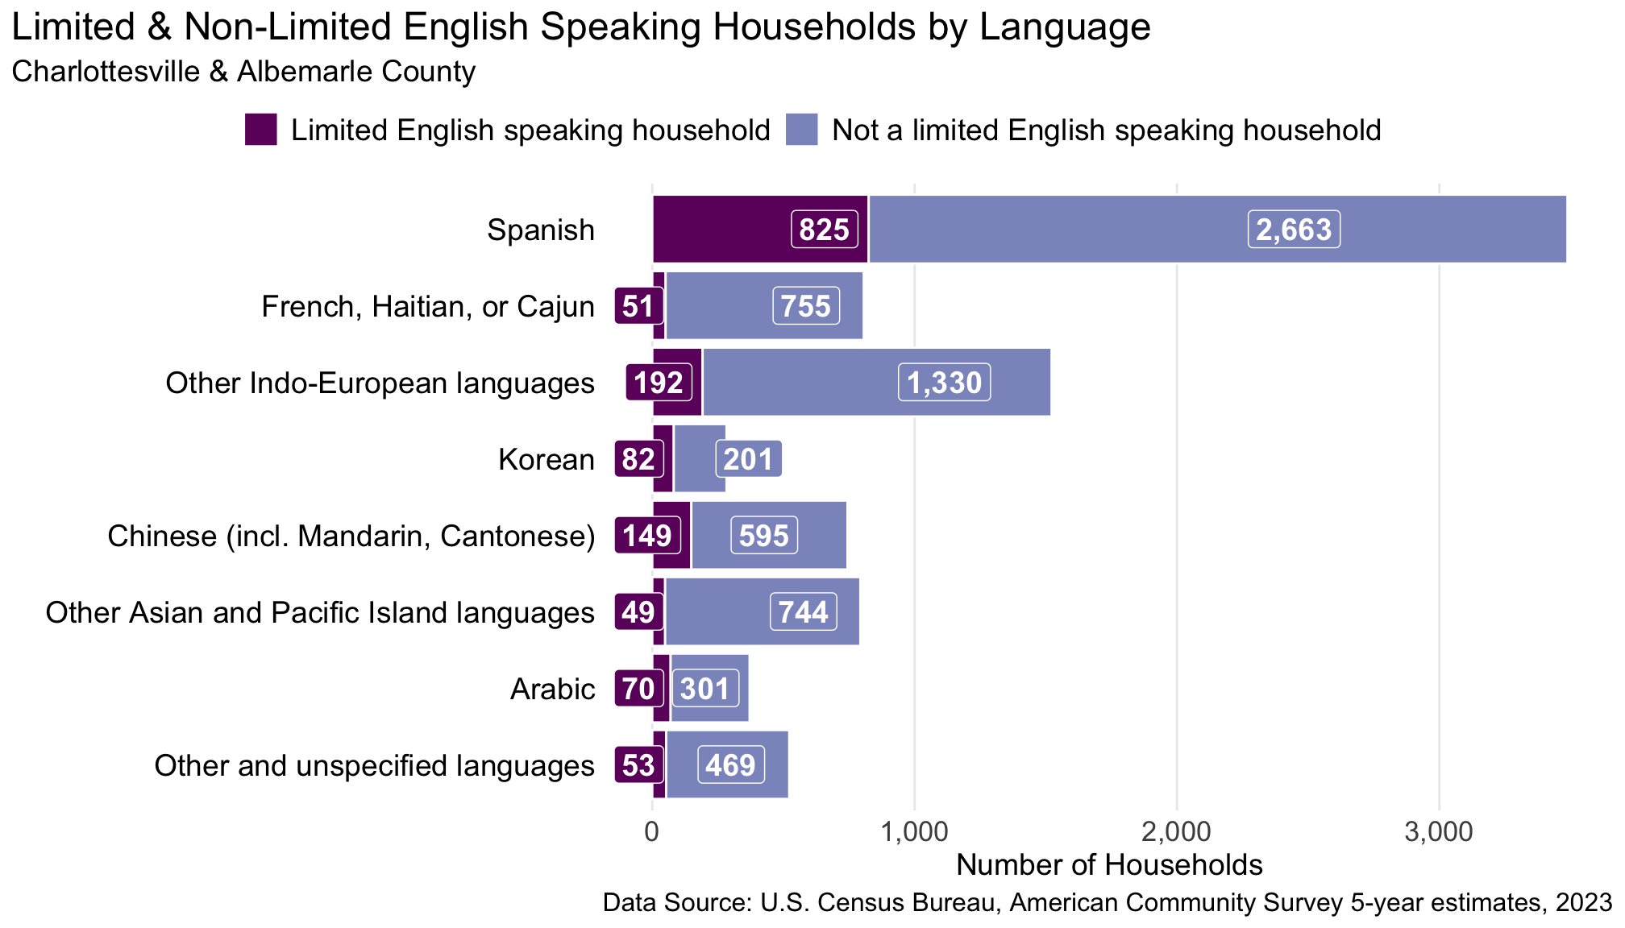

Figure 1.4: Limited & Non-Limited English Speaking Households by Language, 2023. Of the approximately 1,475 linguistically isolated households, 825 speak Spanish, 149 Chinese (incl. Mandarin, Cantonese), 70 Arabic, 82 Korean, 49 Other Asian and Pacific Island languages, 192 Other Indo-European languages, 53 other and unspecified languages.

Both multilingual households and limited-English speaking households span across many languages, pointing to the region’s cultural diversity (Figure 1.4). Among the primary language categories, the greatest number of limited-English speaking households and of multilingual households speak Spanish. The second most common language among limited-English households is Chinese, followed by other Indo-European languages, including Portuguese, German, Persian, and Hindi to name but a few.

### Disability

Over 15,000 residents in the combined Charlottesville and Albemarle region live with some form of disability. Resources and policies that support access and well-being for people with disabilities benefit all residents while enhancing the quality of life for those most impacted.

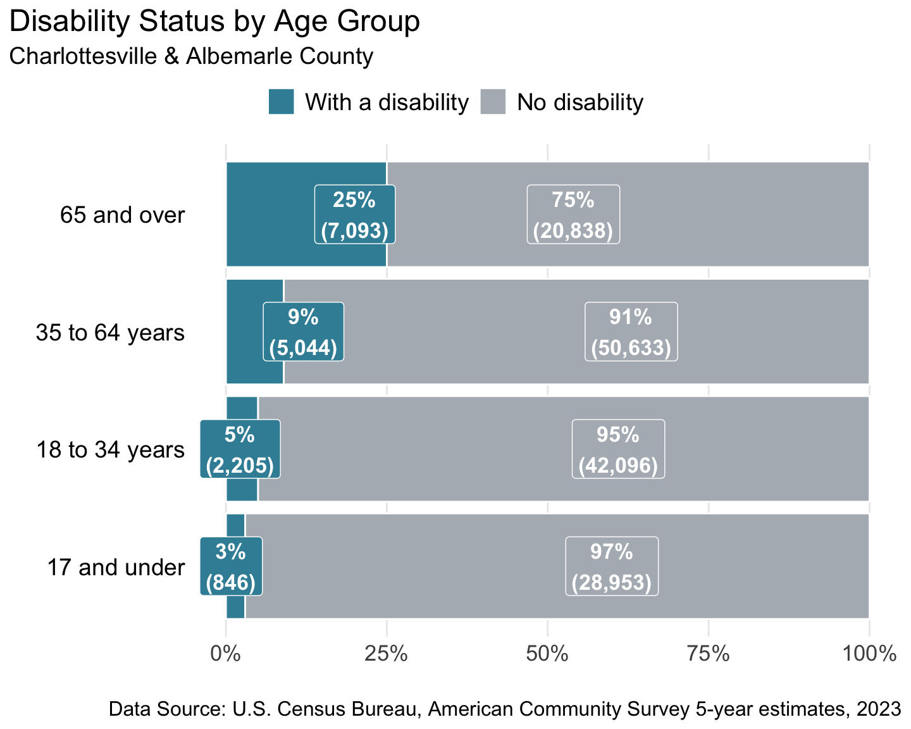

Figure 1.5: Disability Status by Age Group, 2023. Approximately 15,188 people identify as having a disability, with nearly half of those aged 65 and older (7,093 people).

While the majority of residents with a disability are aged 65 or over, people across all life stages experience disability (Figure 1.5). The most commonly reported disabilities are those often associated with aging: ambulatory and cognitive difficulties and challenges with living independently (Figure 1.6).

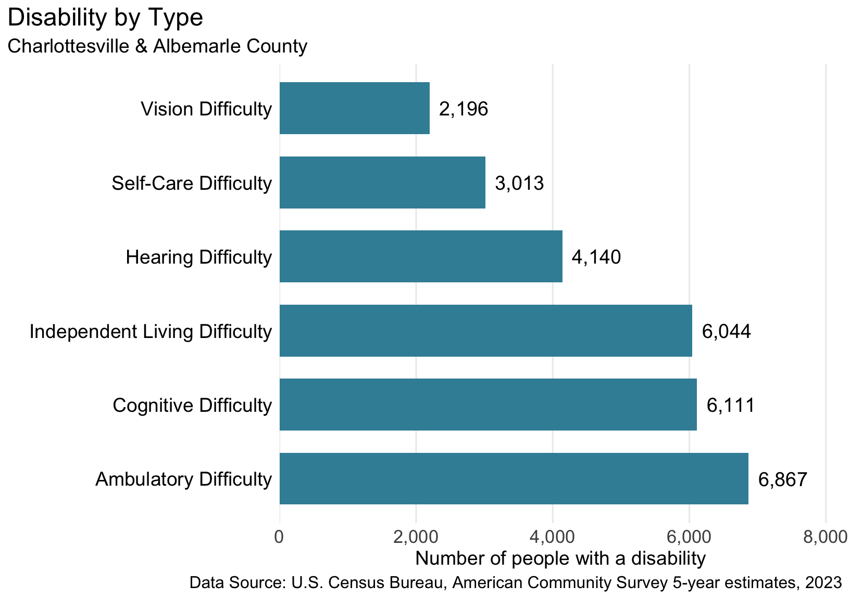

Figure 1.6: Number of people identifying as having a particular disability, 2023. Census-defined categories and the number of people include hearing difficulties (4,140), vision difficulties (2,196), cognitive difficulties (6,111), ambulatory difficulties (6,867), self-care difficulties (3,013), and independent living difficulties (6,044).

## Human Development Framework

### The Human Development Index

The Human Development Index (HDI)[4] is a metric that assesses well-being along three axes: health, access to knowledge, and living standards. The HDI goes beyond simple measures of income or economic productivity to capture interconnected indicators of human well-being. The components of HDI incorporate multiple and mutually reinforcing sectors: health, education, housing, and more. In this way, the HDI mirrors the social determinants of health, a framework that acknowledges the way health and well-being is shaped by the many conditions in which we live.[5] By looking at a wide array of outcomes and people, the HDI departs from methods that focus primarily on conditions of poverty, which may reinforce the sense that our common conditions are not relevant to the whole community.

This report employs an adapted version of the HDI, the American Human Development Index (AHDI), created by Measure of America of the Social Science Research Council to be estimated at smaller geographic levels, such as states and counties, and to speak more directly to the American context of an affluent democracy.

### AHDI in the Region

Using the methodology developed by Measure of America, each component of AHDI—health, access to knowledge, and living standards—is scored on a 0 to 10 scale for a specific geography.[6] The AHDI is the average of these three scores: each component carries equal weight in the composite index as all carry equal importance for community well-being.

The health component is calculated using life expectancy at birth. Access to knowledge uses two critical indices: educational attainment and school enrollment. Educational attainment includes three measures: the percentage of the population aged 25 years and older who have earned at least a high school diploma or equivalent, at least a bachelor’s degree, or an advanced degree (master’s, professional, doctoral, etc.). School enrollment is the percentage of the population between the ages of 3 and 24 that are currently enrolled in a public school, private school, college or university. The living standards component of the AHDI is calculated using median personal earnings.

The following table shows AHDI for Albemarle County, the City of Charlottesville, the combined region, and Virginia overall:

**Table 1:** **American Human Development Index: Local and State-wide Comparison**

|  |  | **Health** | **Access to Knowledge** | | | | **Living Standards** |
| --- | --- | --- | --- | --- | --- | --- | --- |
| **American HD Index** | Life Expectancy (years) | At Least High School Diploma | At Least Bachelor’s Degree | Graduate Degree | School Enrollment | Median Earnings (2023 $) |
| Charlottesville & Albemarle Combined | 7.0 | 81 | 94% | 61% | 31% | 86% | $48,041 |
| Albemarle | 7.3 | 82 | 94% | 61% | 31% | 85% | $51,922 |
| Charlottesville | 6.2 | 79 | 93% | 61% | 33% | 87% | $38,285 |
| Virginia | 5.8 | 78 | 91% | 41% | 18% | 76% | $49,405 |
| United States | 5.3 | 78 | 89% | 35% | 14% | 76% | $44,587 |
| Data Sources: *Life Expectancy:* County Health Rankings, 2024. *Education and Earnings:* U.S. Census Bureau, American Community Survey 5-year estimates, 2023. | | | | | | | |

As Table 1 shows, the AHDI for Albemarle County is higher than that of Charlottesville and Virginia overall, and the AHDI for Charlottesville is slightly above the state average. The primary difference between the AHDI of Albemarle and Charlottesville is due to higher earnings reported by Albemarle residents relative to those in Charlottesville. Both Charlottesville and Albemarle score higher than the state in large part due to the high degree of educational attainment among residents.

The specific Charlottesville and Albemarle reports show the AHDI for additional benchmark localities and provide comparisons by census tract. This combined regional report delves further into each of the components of AHDI—health, access to knowledge, and living standards—to evaluate our region overall.

## A Long and Healthy Life: Health Profile

### Life Expectancy

The primary AHDI indicator of health is life expectancy. The Blue Ridge Health District’s MAPP2Health report also uses life expectancy as a “key population health measure used to gauge health and longevity.”[7] Life expectancy at birth is the average number of years a baby born today is expected to live given current mortality patterns.

The average lifespan in the United States has declined in recent years, giving cause for concern: in 2022, U.S. life expectancy had fallen to 76.4 years, the lowest point in almost twenty years.[8] Experts pointed to the ongoing impacts of the COVID-19 pandemic and rising rates of drug overdoses as major contributors to the striking national decline in life expectancy.[9]

By 2023, national-level life expectancy appeared to be approaching pre-2020 levels, increasing from 76.4 to 78.4 years.[10] During the same period, life expectancy in Albemarle County, Charlottesville, and Virginia as a whole have remained slightly above the national average (Figure 3.1).

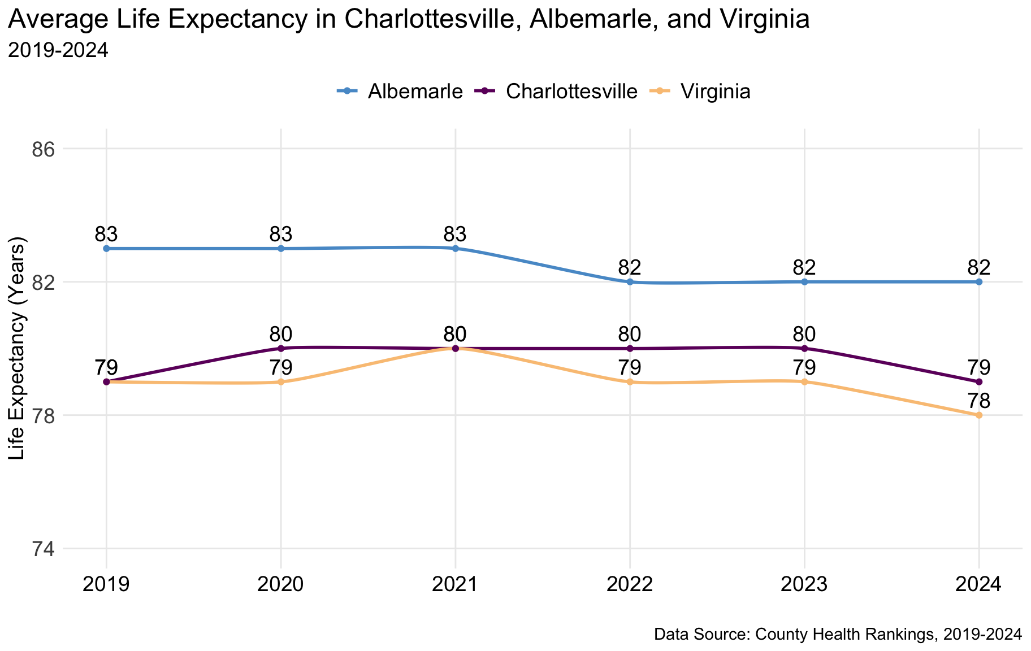

Figure 3.1: Average Life Expectancy, 2019-2024. Life expectancy in 2024 is 79 years for Charlottesville, 82 years for Albemarle, and 78 years for Virginia.

While the region did not exhibit the same national-level declines in life expectancy from 2020-2022, Albemarle County’s life expectancy fell from 83 in the period from 2019-2022 to 82 in 2022 where it has remained. Life expectancy in Charlottesville increased from 79 to 80 between 2019 and 2020, remaining at 80 years until 2024, when expectancy fell to 79 once again. Life expectancy in the county remains three years longer than life expectancy in the City of Charlottesville.

Nationally, rural areas have had minimal increases in life expectancy over the last decades. Rural regions, particularly in the American South, face a variety of public health challenges, including high levels of gun-related deaths and substance use disorder.[11] Affluent areas, however, typically experience greater longevity. Albemarle contains areas of rurality that overlap with areas of affluence, complicating easy characterization.

### Primary Care and Mental Health Care Providers

The insufficient provision of primary care and mental health care are growing crises in the United States and are felt most acutely in rural areas of the country. At present, roughly 83 million people in the US lack access to a primary care physician.[12] Similarly, there are long-standing and acute provider shortages within the American mental health care system: the amount of psychiatrists per 100,000 US individuals fell by about 10% from 2003 to 2013.[13] In rural areas, roughly 80% of counties lack practicing psychiatrists.[14] These trends provide context for understanding changes in mental health and primary care providers in the Charlottesville-Albemarle area.

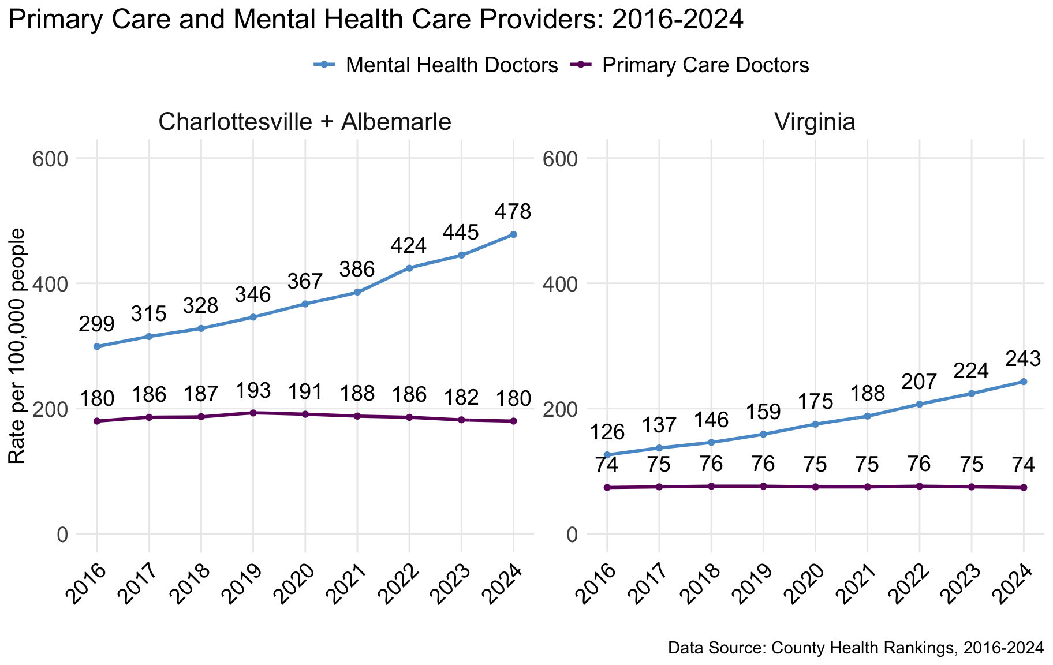

Figure 3.2: Primary care and mental health care providers, 2016-2024. In Charlottesville and Albemarle, the rate of primary care providers was 180 providers per 100,000 people in 2024. The rate of mental health providers was 478 providers per 100,000 people in 2024.

The region’s supply of mental health care providers per 100,000 people has grown steadily each year since 2016, increasing from 299 in 2016 to 478 in 2024, a roughly 60% increase. At the same time, the region’s supply of primary care physicians has remained static: there were 180 primary care doctors per 100,000 individuals in the area in 2024, precisely the same number as in 2016.

These health care provider trends parallel patterns in Virginia as a whole, though care provider rates are consistently higher in the Charlottesville-Albemarle region. The state as a whole is consistently ranked low on mental health workforce availability. The most recent report from Mental Health America ranks Virginia 38th, with an estimated 450 individuals for every mental health provider, compared to a national estimate of 340 individuals for every mental health provider.[15]

### Health Insurance

Access to multiple high quality health centers like UVA Health and Sentara Healthcare is a major contributor to well-being in Charlottesville and Albemarle. However, accessible and affordable medical services are not universally available to residents, as evidenced by the area’s stark disparities in health insurance coverage. Within Charlottesville and Albemarle, roughly 6% of residents lacked health insurance in 2023 (Figure 3.3). Yet, rates varied considerably between different racial and ethnic groups. In 2023, about 3% of the region’s white residents lacked health insurance, whereas 24% of Hispanic individuals in the area were without health insurance.

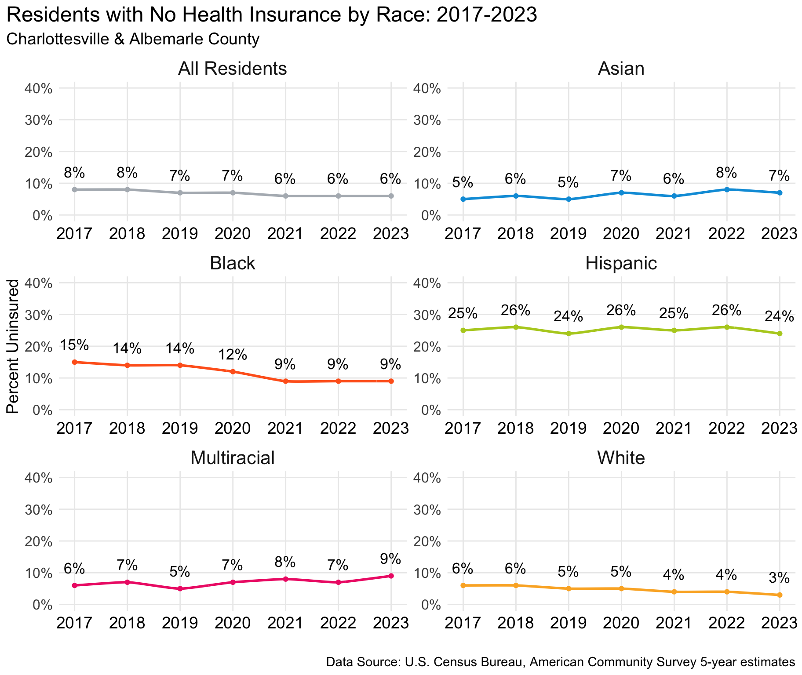

Figure 3.3: Residents with No Health Insurance, 2017-2023. Overall, approximately 6% of residents did not have health insurance in 2023. This value is higher for Hispanic residents, at 24% in 2023.

The overall uninsured rate among residents of Charlottesville and Albemarle has declined in recent years, dropping from 8% in 2017 to 6% in 2023. Among different racial/ethnic groups, Black residents have seen the greatest decline in uninsured rates, which decreased from 15% in 2017 to 9% in 2023. For white residents, uninsured rates also declined, from 6% in 2017 to 3% in 2023. The uninsured rate for Hispanic residents was 25% in 2017 and 24% in 2023; and uninsured rates for Asian residents increased from 5% in 2017 to 7% in 2023.

It is important to understand that the composition of particular racial and ethnic groups is not necessarily static and may involve shifting settlement patterns as new residents arrive and others move.

Ongoing inequities in regional insurance rates should also be understood within the broader policy context of Virginia’s 2019 Medicaid expansion. In January of 2019, Virginia altered eligibility criteria for Medicaid in accordance with the Affordable Care Act, substantially increasing access to coverage for state residents.[16] Prior to this expansion, adults without children were ineligible for Medicaid coverage, and parents could only maintain eligibility with incomes up to 38% of the federal poverty level.[17] The 2019 expansion established eligibility for adults with and without children at up to 138% of the federal poverty level, significantly boosting coverage for state residents under Medicaid by 9 to 11 percent.[18]

Hispanic residents in Charlottesville and Albemarle are far more likely to be uninsured than any other racial or ethnic group, mirroring nationwide trends. Hispanic people saw the greatest decline in uninsured rates after the implementation of the Affordable Care Act, with national uninsured rates for Hispanic people decreasing from 33% in 2010 to 21% in 2015.[19] Hispanic Americans still had the second highest uninsured rate among racial/ethnic groups in the nation in 2022 (at 18%), just below the American Indian / Alaskan Native population’s 19.9% uninsured rate.[20] Uninsured rates for Hispanic residents of Charlottesville and Albemarle exceeded nationwide rates by about 8 percentage points in 2022, suggesting a particularly acute need for focused local policy interventions to insure access to medical care.

### Access to Parks and Exercise Opportunities

Access to parks and green spaces is increasingly understood as a vital component of health and wellness. The public health benefits of park access include physical, mental, and environmental well-being.[21] In addition to serving as a place to exercise or experience nature, parks are essential components of regional and neighborhood-level identity, acting as important spaces for community building. As green spaces which often feature tree cover, parks can also provide a refuge from rising heat and other environmental stressors.

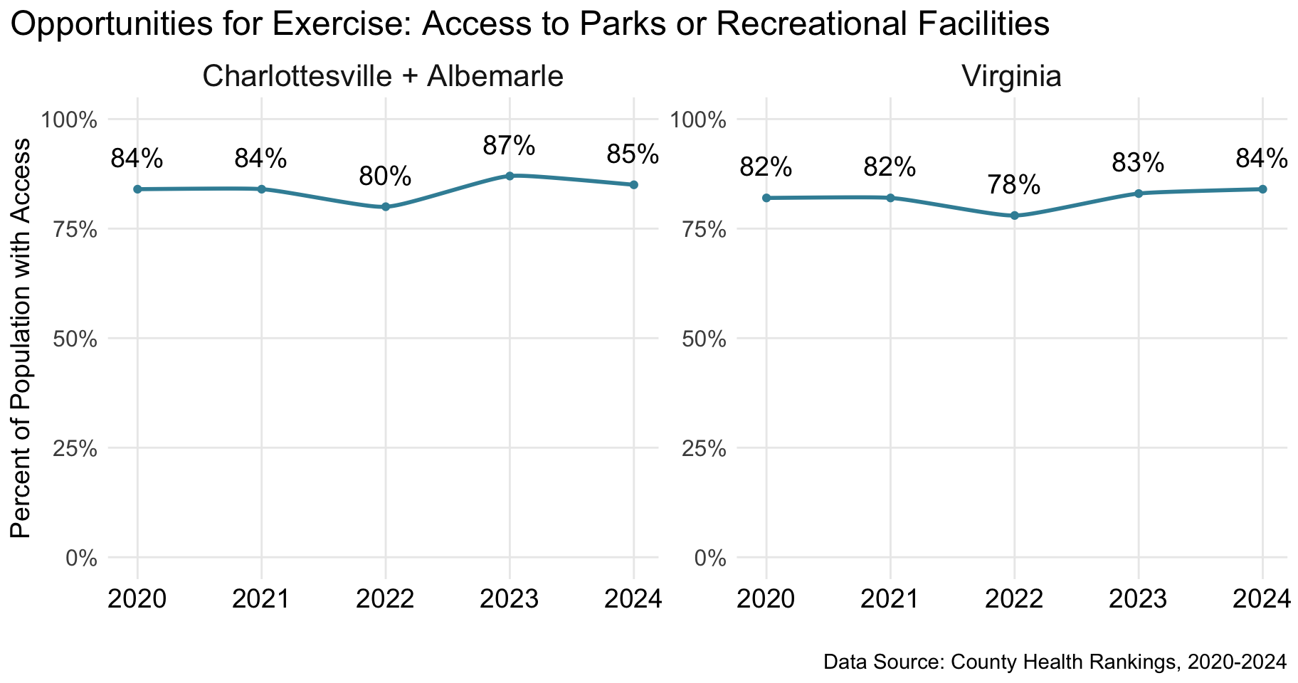

Figure 3.4: Opportunities for Exercise: Access to Parks or Recreational Facilities, 2020-2024. The percent of residents with access to parks and exercise opportunities in Charlottesville and Albemarle County was 85% in 2024.

Opportunities for exercise measures whether an individual has adequate access to parks or recreational facilities, defined here as living within a half mile of a park, within one mile of a recreational facility (if in an urban area), or within three miles of a recreational facility in a rural area.[22] Within Charlottesville and Albemarle, resident access to exercise opportunities has remained high over the past five years, slightly exceeding access in Virginia as a whole. In 2024, 85% of residents had access to a park or recreational facility, like a YMCA.

Expansions in regional park acreage, particularly in areas lacking existing green space, may help extend the well-known health benefits of parks to more residents. The region is making positive progress towards increasing park accessibility: the area’s newest park, Biscuit Run located along Route 20 in Albemarle County, opened on December 14, 2024.[23]

## Access to Knowledge: Education Profile

Educational attainment directly influences employment and earnings, which in turn influence access to housing, food, healthcare, transportation, and more. Charlottesville and Albemarle benefit from a highly educated population overall. However, overall high rates of formal education can conceal the challenges faced by those afforded fewer educational opportunities and support.

### Degree Attainment

The AHDI incorporates formal educational attainment: the percent of the adult population with a high school degree, with a bachelor's degree, and with a graduate degree and the percent of the youth population enrolled in school. The figure below shows the percent of residents aged 25 and over who have attained each degree level across the last five years.

By these measures, the combined population of Charlottesville and Albemarle has seen increased educational attainment, especially in the percent of the adult population with a four-year college degree. In 2018, 53% of city and county residents had a college degree; in 2023 this had grown to 61%, or more than three-fifths of the adult population. This increase could reflect growth of education among residents, a shift in the composition of who lives in the city and the county, or a combination of both.

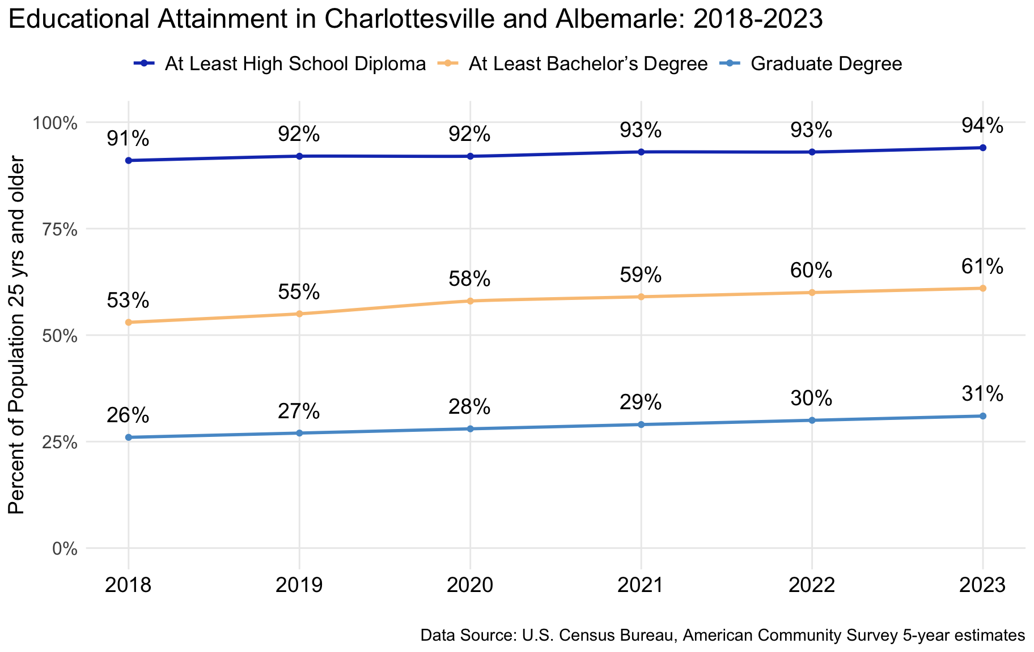

Figure 4.1: Educational Attainment in Charlottesville and Albemarle, 2018-2023. In 2023, for residents 25 years and older in Charlottesville and Albemarle County, 94% completed high school, 61% held a bachelor’s degree and 31% had a graduate degree.

Figure 4.2 below shows how degree attainment varies across residents by race and ethnicity in the combined population. Overall, roughly 6 in 10 adult residents in Charlottesville and Albemarle have a bachelor’s degree. This is nearly the same for white residents, at more than 6 in 10 (66%), while only around 2 in 10 Black residents (26%) and 4 in 10 Hispanic residents (40%) have the benefit of a four-year college education.

These differences may be due to multiple barriers to higher education, including affordability, geographic accessibility of college and differential experiences with secondary education institutions.

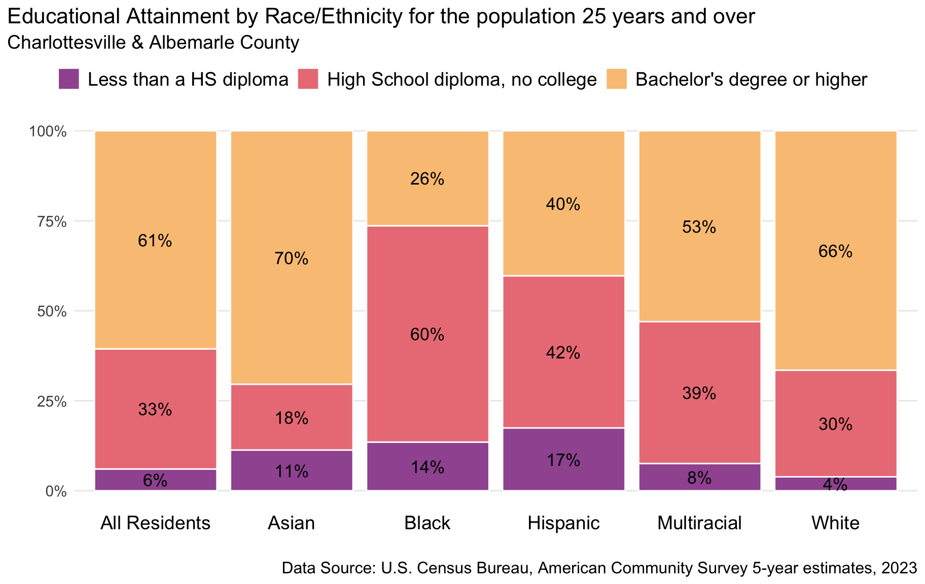

Figure 4.2: Educational Attainment by Race/Ethnicity for the population 25 years and over, 2023. While 61% of residents overall have a bachelor’s degree or higher, 26% of Black residents, 40% of Hispanic residents, and 66% of white residents have BA’s or higher.

### School Enrollment

School enrollment measures how many young people, ages 3 to 24 years, currently attend a public school, private school, college or university.[24] In Charlottesville and Albemarle County, enrollment in formal schooling has remained steady across the last five years, from 84% in 2018 to 86% in 2023. Given the disruption of the worldwide COVID-19 pandemic beginning in March 2020, with the move to online schooling and hybrid school schedules, this stability is reassuring.

Breaking this down by age groups shows that 97-99% of youth ages 10 to 17 years old are enrolled in formal schooling (Figure 4.3). This value is 95% for 18 and 19 year olds, an age range that captures students both pre- and post-high school graduation. For younger children, 69% of 3 to 4 year olds were enrolled in school. For young adults ages 20 to 24 years old, 67% were enrolled at a college or university.

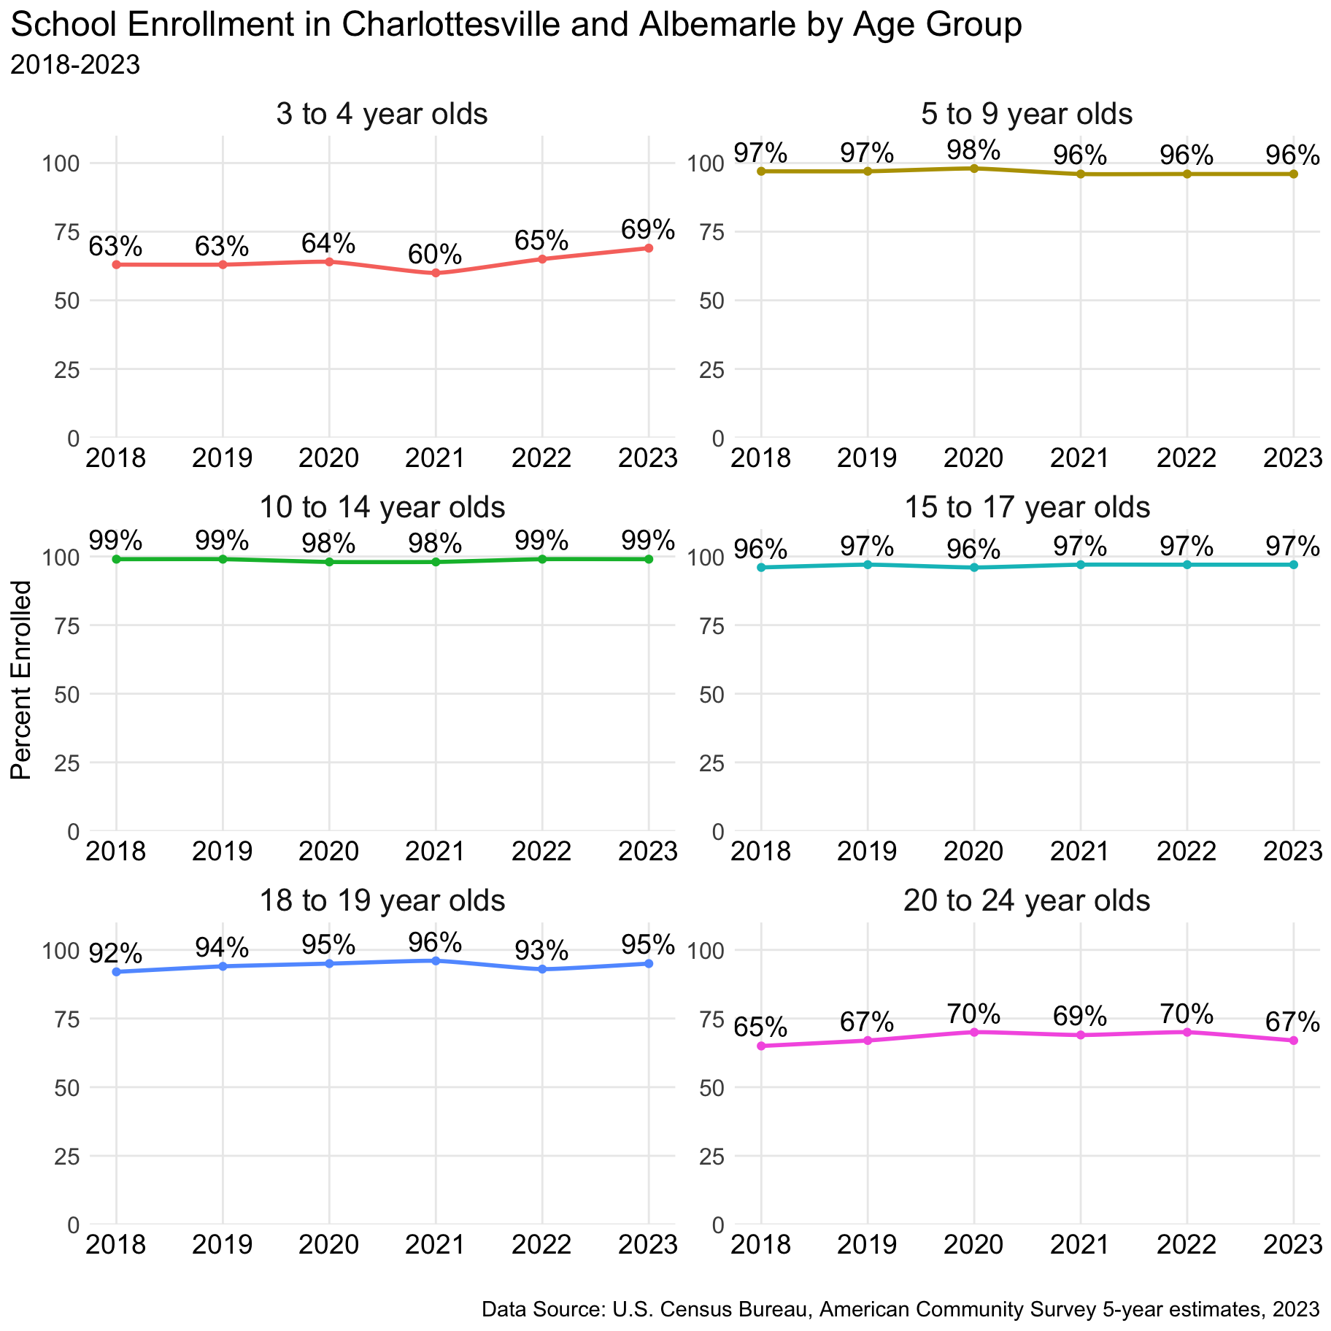

Figure 4.3: School Enrollment By Age Group in Charlottesville and Albemarle, 2018-2023. In 2023, 86% of 3 to 24 year olds in Charlottesville and Albemarle were enrolled in school. Most of those not enrolled in school are in the age groups of 3 to 4 year olds and 20 to 24 year olds.

### Child Care

Educational opportunities begin before formal schooling with the availability or absence of early childhood education and quality childcare. Access to affordable childcare and early childhood education is essential for working families, enabling parents, guardians, and other caring adults to maintain stable employment. Childcare and preschools are not tied to residential jurisdiction, so the availability of early childhood education centers and seats is best understood regionally.

The table below combines the locality reports from Child Care Aware of Virginia as of January 2025. In Charlottesville and Albemarle combined, there were approximately 6,000 slots in child care centers, preschools, and family child care homes.[25]

**Table 2:** **Child Care Supply**

|  | Albemarle | | Charlottesville | | Combined | |
| --- | --- | --- | --- | --- | --- | --- |
| Centers | Seats | Centers | Seats | Centers | Seats |
| Child Care Centers | 27 | 2073 | 32 | 2757 | 59 | 4830 |
| Preschools | 24 | 339 | 28 | 597 | 52 | 936 |
| Family Child Care Homes | 11 | 108 | 16 | 136 | 27 | 244 |
| School Age Only Programs | 23 | 867 | 24 | 2827 | 47 | 3694 |
| Total | 85 | 3387 | 100 | 6317 | 185 | 9704 |
| Data Source: Child Care Aware of Virginia | | | | | | |

There are approximately 6,200 children under age 6 who live with two working parents or with a single parent who works.[26] In addition, there are more than 9,200 children under 6 in Charlottesville and Albemarle overall. Among some of the families with a parent at home, that parent may prefer to work if they had access to affordable and quality care for young children.

### Civil Society

A thriving environment provides opportunities for adults to make social connections, volunteer in their communities, and engage civically. Social capital, or the norms, obligations, and information that develop within a network of citizens, promotes collective action, economic growth, institutional accountability, and individual well-being. The presence of voluntary associations is one common indicator of a community’s social capital. Charlottesville and Albemarle benefit from a robust civic sector, with more than 200 membership organizations (Figure 4.4), or more than 13 organizations per 10,000 people.

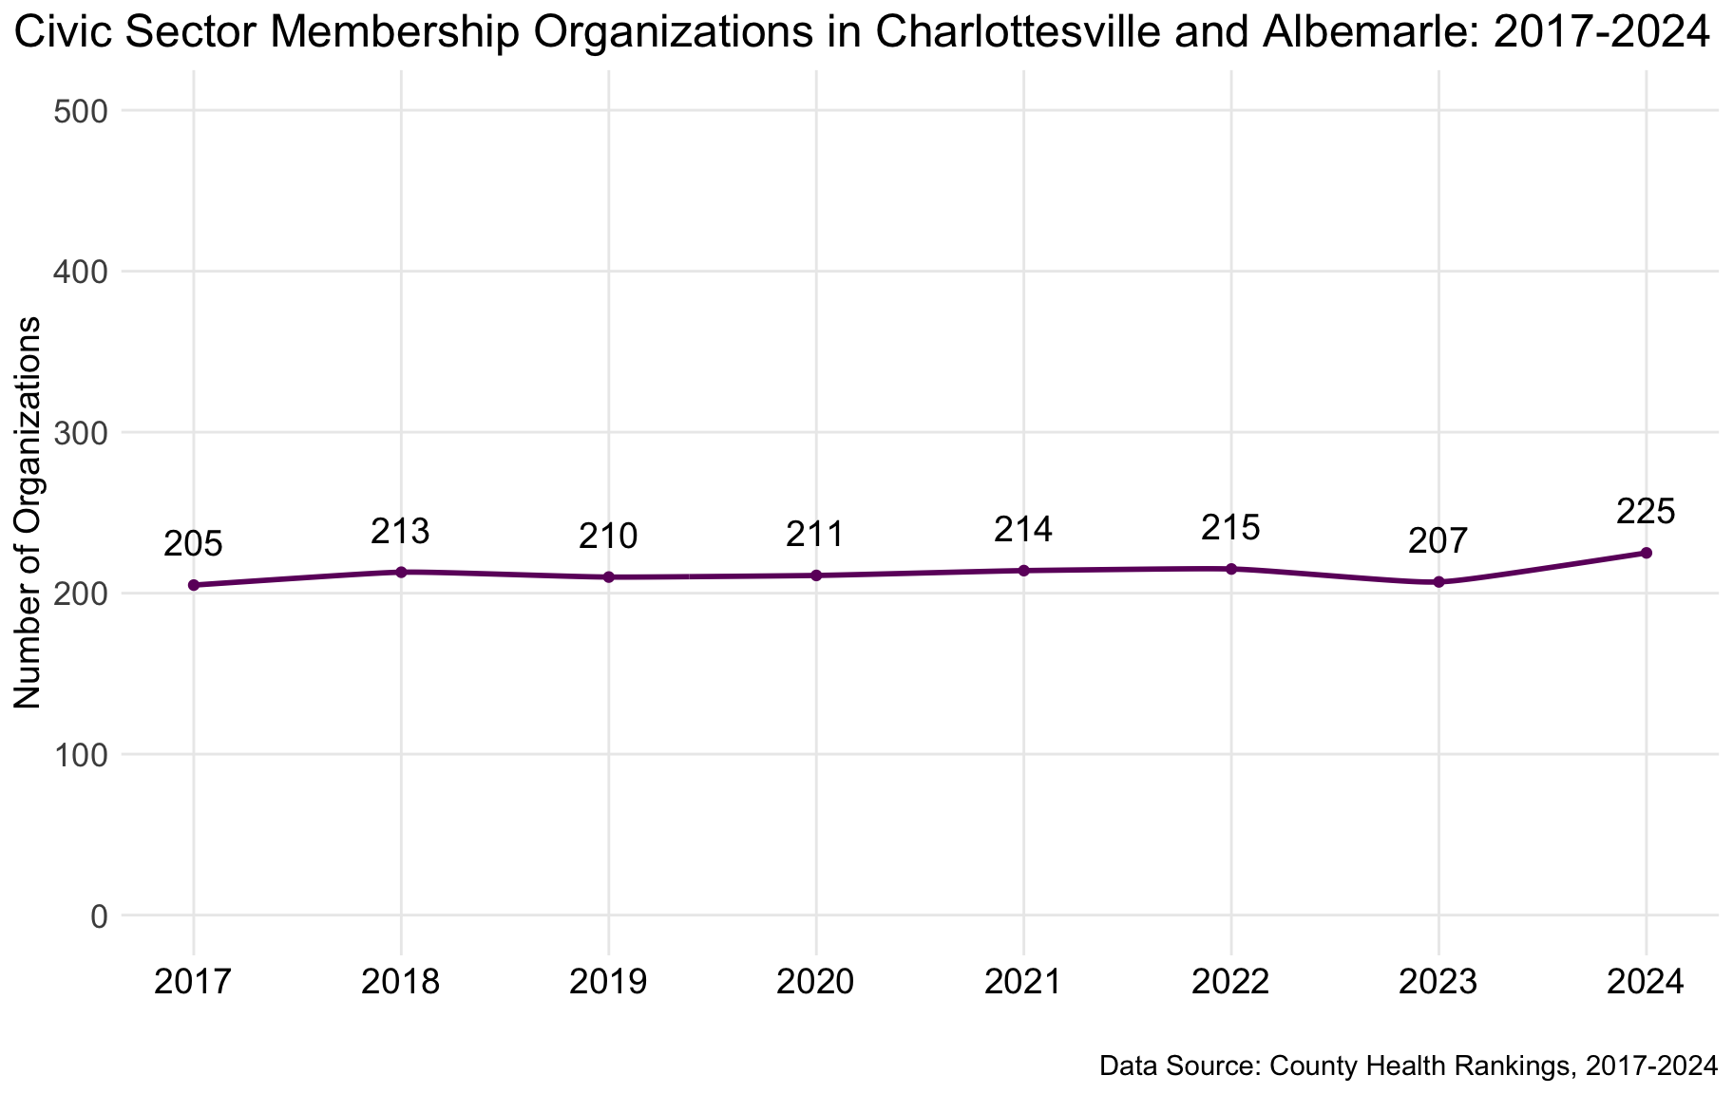

Figure 4.4: Civic Sector Membership Organizations, 2017-2024. In 2024 there were 225 membership organizations in Charlottesville and Albemarle.

Measures of social capital produced the group, Opportunity Insights, further underscore the robust connections within our local region.[27] According to their data, the combined Charlottesville-Albemarle area is in the 62nd percentile of civic engagement and in the 78th percentile of economic connectedness.[28] In short, by multiple measures, the city and county have significant resources with which to promote engagement.

## Decent Standard of Living: Economic Security and Housing Profile

A decent standard of living is centered on income—a means to meet essential needs like housing, security, and food. Standard of living is captured in the AHDI through measures on earnings. This Charlottesville-Albemarle regional report supplements data on earnings and income with measures of housing availability, affordability, and stability, centering the basic need of safe shelter.

### Earnings and Income

The steady growth in median personal earnings between 2012 and 2023 speaks to the ongoing expansion of economic opportunities in Charlottesville and Albemarle (Figure 5.1). Median earnings represent the value for which half of workers earn more and half earn less. Consistent increases in median personal earnings are visible both before and after adjusting earnings for inflation.

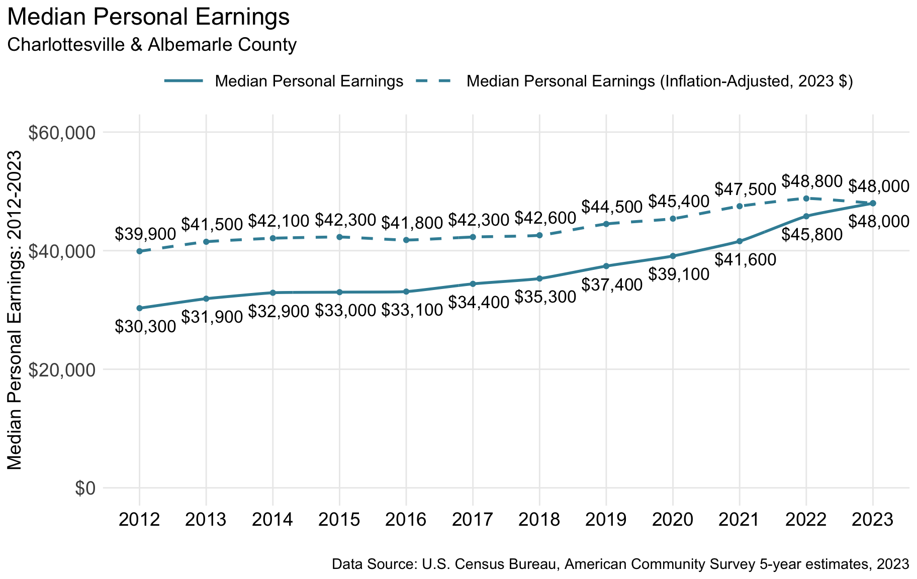

Figure 5.1: Median Personal Earnings, 2012-2023. The median personal earnings in Charlottesville and Albemarle in 2023 was $48,000.

From 2012 to 2023, median personal earnings grew from $30,300 to $48,000; adjusted for inflation, earnings increased from $39,900 to $48,000 in this period (roughly 20%). Though these data speak to the economic dynamism of Charlottesville and Albemarle, rapid increases in the regional cost of living (particularly housing) may be eclipsing these gains in earnings for many of the area’s residents.

Median earnings (Figure 5.1) reflect the wages or salaries individuals receive from work. Median household income (Figure 5.2) arises from the combined earnings of members of a household, along with other sources of income including interest and trusts, and retirement income and social security. There are significant racial and ethnic disparities in median household incomes in Charlottesville and Albemarle.

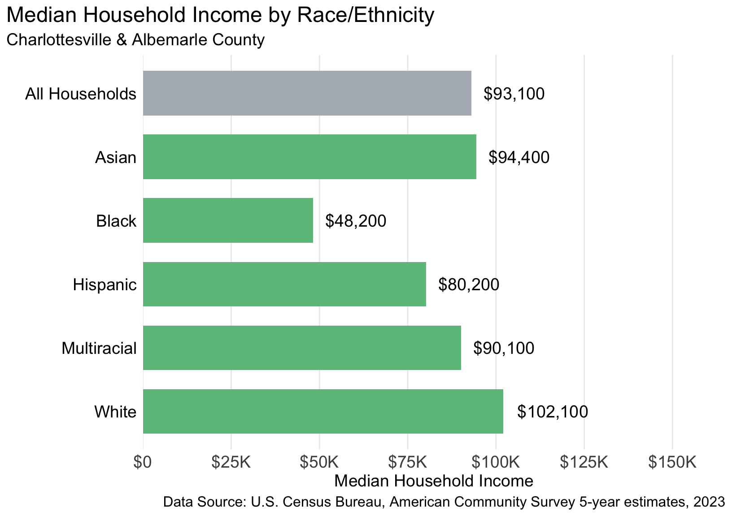

Figure 5.2: Median Household Income by Race/Ethnicity, 2023. Median annual income for all households in Charlottesville and Albemarle County is $93,100. For white households, this income is $102,100/year, and $48,200/year for Black households.

The median household income among all households in Charlottesville and Albemarle was $93,100 in 2023. Asian and white households had incomes above this amount, at $94,400 and $102,100, respectively. Hispanic and multiracial households had incomes less than the regional median income, at $80,200 and $90,100. Black households had incomes far below the regional median, at $48,200. This annual income is less than half of the income of white households, highlighting pressing concerns about the equitable distribution of regional economic opportunities.

### Where People Live and Work

The combined Charlottesville-Albemarle area enjoys a robust labor market. Not all local workers live within the city and county boundaries, and not all employed residents of the area work in the two localities. Figure 5.3 below shows the number of working individuals who both live and work within the city and county boundaries, the number who live in the area but work outside of it, and the number who live outside of Charlottesville and Albemarle but work in the city and county limits.

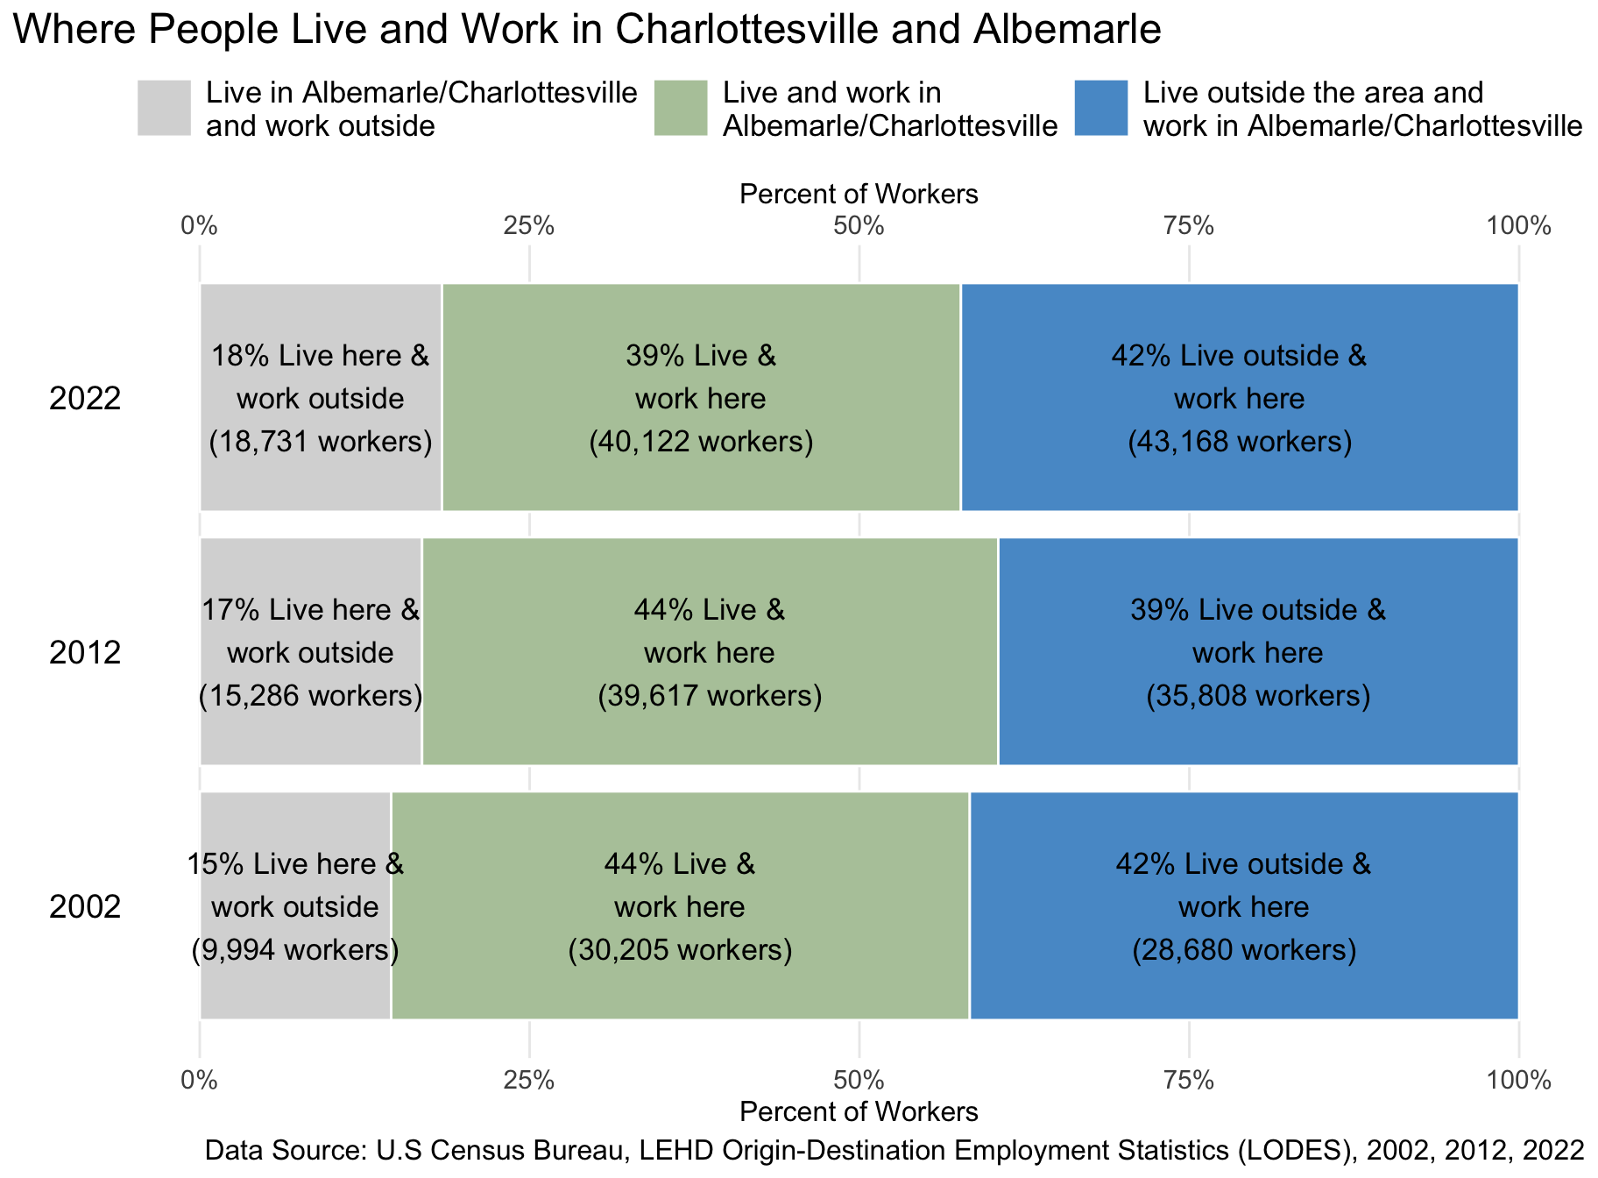

Figure 5.3: Trends in Work and Living Locations in Charlottesville and Albemarle for 2002, 2012, 2022.

Among all working individuals who lived in Charlottesville or Albemarle in 2022 (the grey and green areas in Figure 5.3), over two-thirds worked within the area. However, among those who worked in Charlottesville or Albemarle (the green and blue areas), just over half lived outside of the city and county boundaries. This represents a decline from previous decades, when over half of individuals who worked in Charlottesville or Albemarle also lived here.

The change in the inflow and outflow of workers over time is also telling. From 2002 to 2012, there was growth for each combination of workplace and residence:

* The number of workers flowing into Charlottesville and Albemarle increased by more than 7,000 individuals.
* The number of workers living and working in Charlottesville and Albemarle increased by more than 9,000 individuals.
* The number of workers flowing out of the area for work increased by more than 5,000 individuals.

Between 2012 and 2022, however, most of the growth was in workers flowing into Charlottesville and Albemarle:

* The inflow of workers grew again by more than 7,000 individuals.
* The number of workers both living and working in Charlottesville and Albemarle held steady. While economic opportunities continued to grow, the housing capacity did not keep pace.
* There was additional growth in the number of workers living in Charlottesville and Albemarle but working elsewhere. This category includes both commuters and remote workers and may partly reflect the rise of remote work throughout the COVID-19 pandemic, as Charlottesville has reportedly been a destination for remote workers formerly residing in the Washington D.C. area.[29]

The availability of affordable housing close to workers’ place of employment has ongoing implications for regional equity and general quality of life.

### Housing: Renters and Owners

Income has a broad impact on the choices individuals make. Housing is a significant expense, and in our housing affordability crisis, there often are limited options for those whose wages are not rising enough to meet the regional costs of housing. The figures below show how many households in Charlottesville and Albemarle are homeowners or renters (Figure 5.4), and of those renters, how many are struggling to make rent (Figure 5.5).

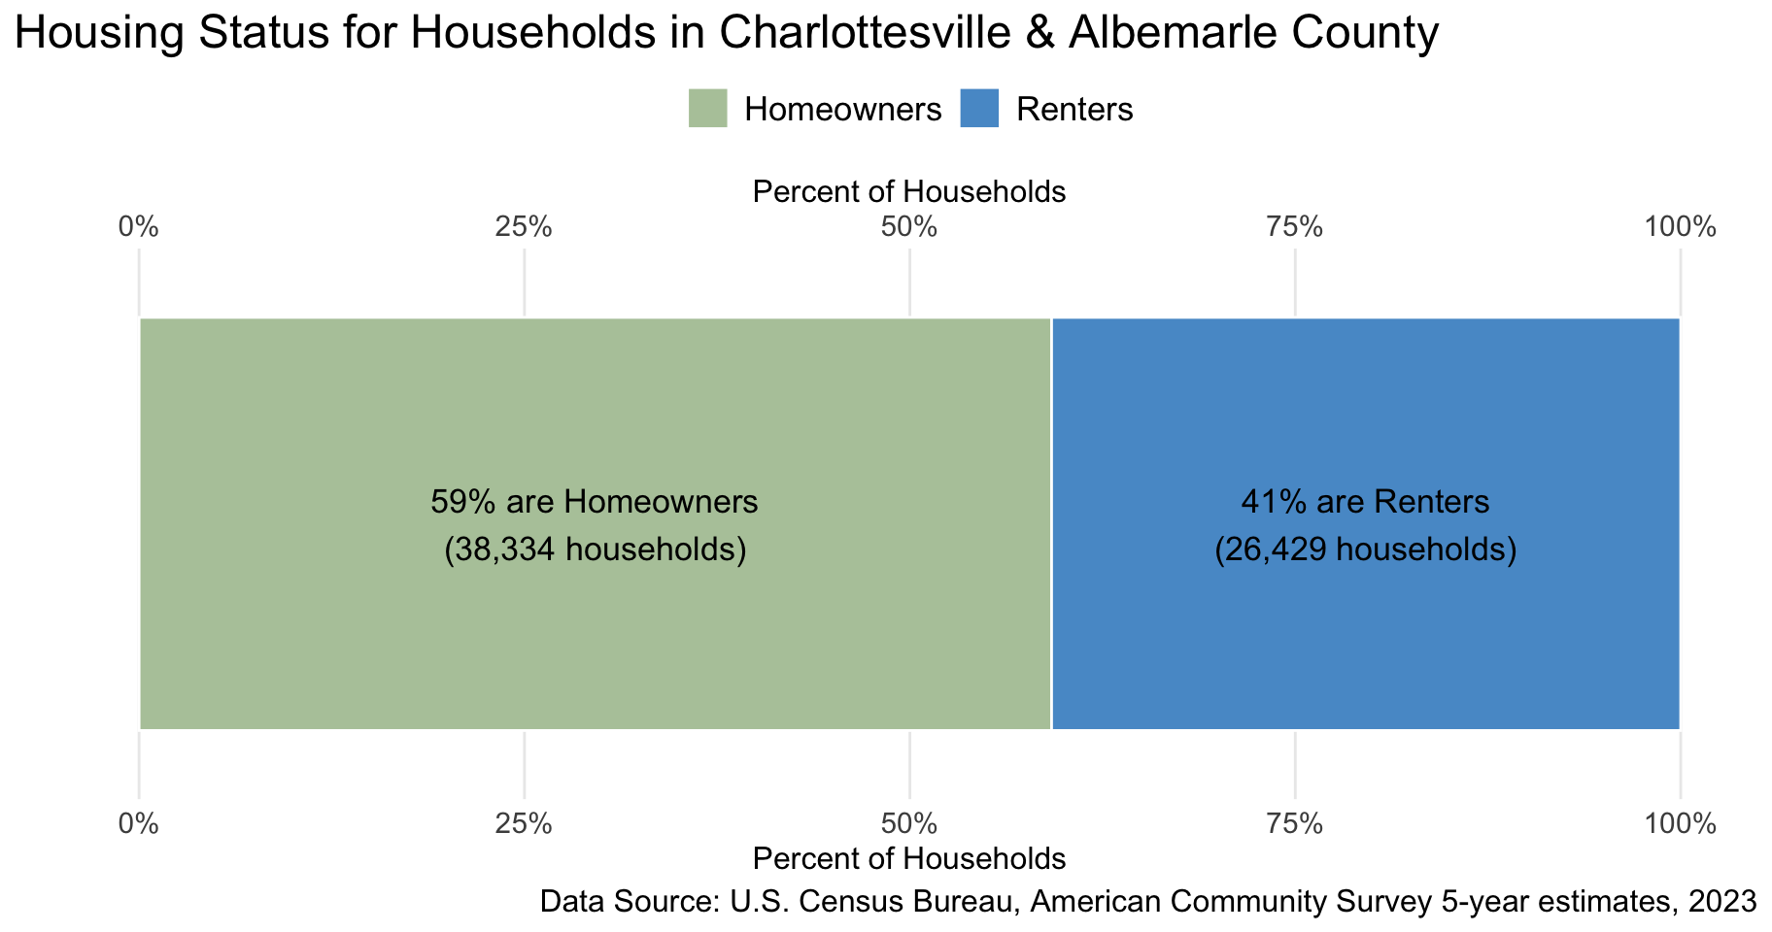

Figure 5.4: Housing Status, 2023. For households in Charlottesville and Albemarle, 59% are homeowners and 41% are renters.

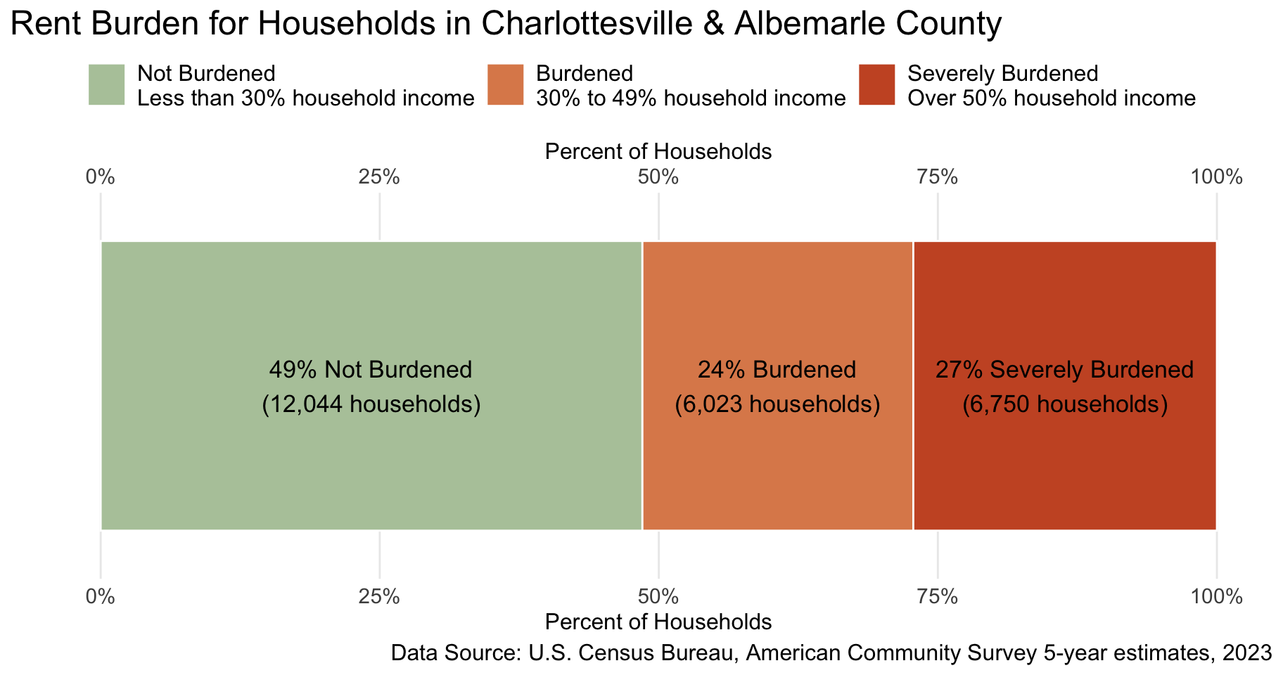

Figure 5.5: Rent-Burdened Households, 2023. In Charlottesville and Albemarle County, 49% of renters are not burdened, 24% are rent-burdened and 27% are severely burdened.

In Charlottesville and Albemarle, over half (59%) of households own their homes. Among the 41% of households who are renters, more than half—nearly 12,800 households—were rent-burdened to some degree. A household is considered to be rent-burdened if 30% or more of their monthly income is spent on housing. If these costs are over 50% of household income, they are considered severely burdened by the cost of housing. In our area, 27% of renters—over 6,700 households—were severely burdened.

### Evictions

One of the most severe consequences of rent-burden is eviction, or forced displacement from one’s home. Evictions are a major component of growing regional housing disparities and reflect broader statewide and national histories of exploitation and exclusion. Figure 5.6 shows both the number of eviction cases filed by landlord representatives in the Albemarle and Charlottesville General District Courts and the number of eviction judgments—cases granting an eviction.

The act of filing an eviction case alone has serious and well-documented consequences for tenants, even in instances when forceful removal does not occur.[30] Tenants who have an eviction case in their legal record often experience long-term housing instability, as future landlords may use this to reject their housing application.

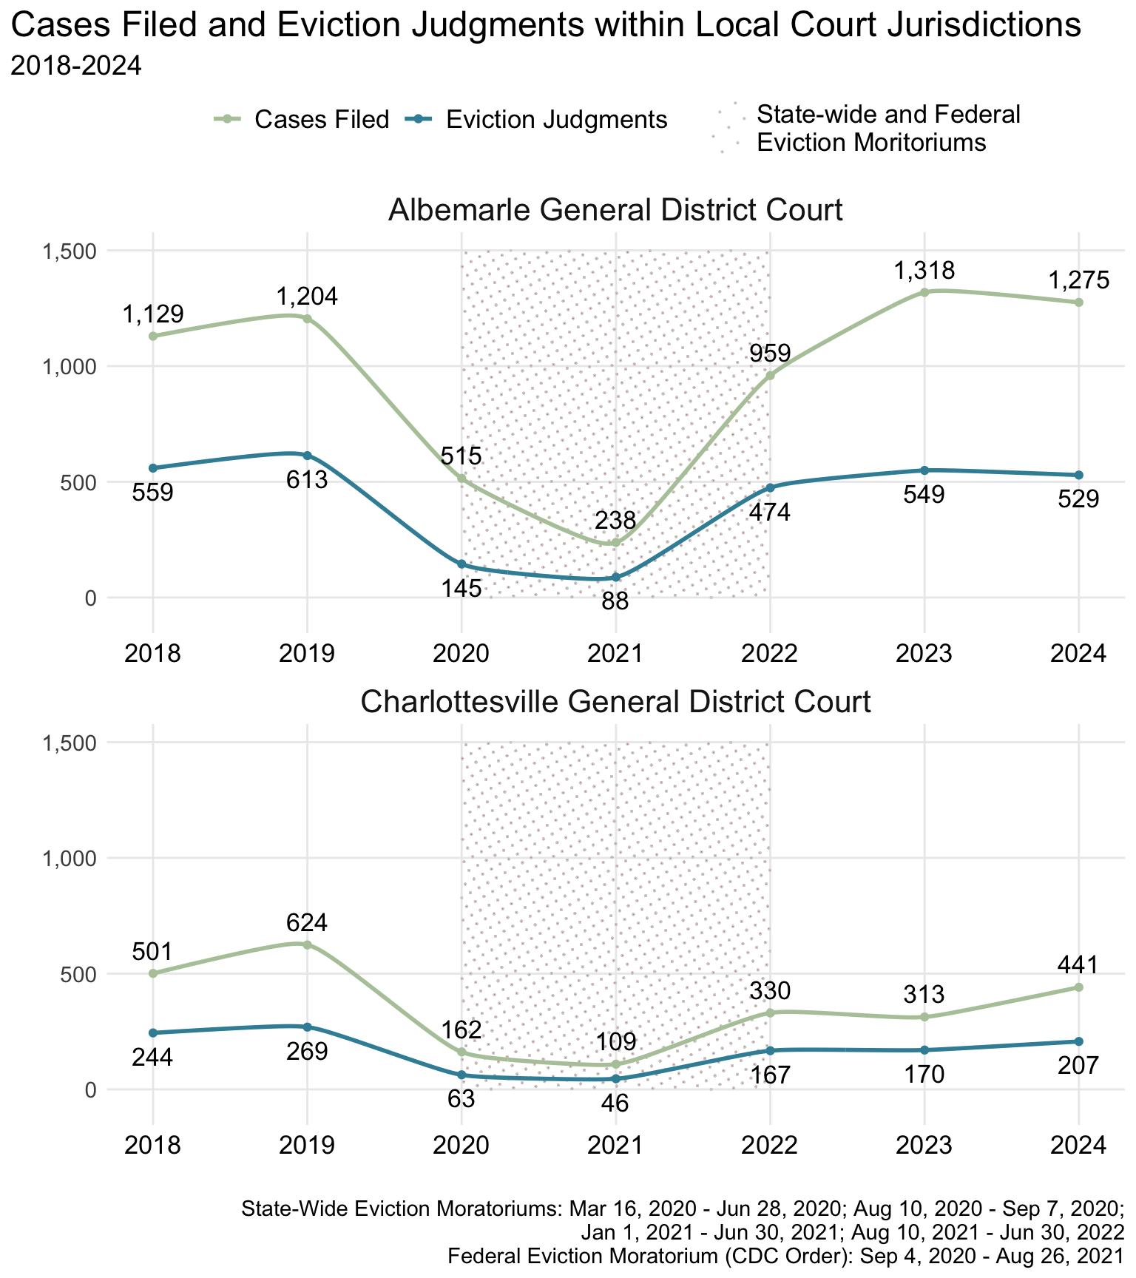

Figure 5.6: Cases Filed and Eviction Judgments within Local Court Jurisdictions, 2018-2024. In 2024, the Albemarle County District Court saw 1,275 eviction cases, with 529 of those given eviction judgements. In the Charlottesville General District Court there were 441 eviction cases with 207 eviction judgements in 2024.

While eviction moratoriums enacted during the COVID-19 pandemic curtailed the number of eviction filings and judgments, the last two years have seen both eviction filings and judgments increase to pre-pandemic levels in the county and begin to rise toward pre-pandemic levels in the city. To prevent evictions, the Thomas Jefferson Planning District, in collaboration with Piedmont Housing Alliance, received a series of Virginia Eviction Reduction Pilot grants in effort to mitigate this rise.[31]

Beyond exacerbating housing instability, research suggests that evictions are a potential driver of regional homelessness.[32] A recent report from HUD’s Office of Policy Development and Research estimates that without the federal eviction moratoriums in 2021, national homelessness would have risen.[33] Therefore, regional responses to homelessness must also address local evictions.

### People Experiencing Homelessness

The City of Charlottesville and Albemarle County work to address homelessness in collaboration with the broader area’s Continuum of Care (CoC), the Blue Ridge Area Coalition for the Homeless (BRACH), which is the federally-required planning body that oversees the provision of services and programs for unhoused people in the region.[34] In addition to administering federal funds, BRACH oversees the annual point-in-time (PIT) count for the region, which includes Greene, Fluvanna, Louisa, and Nelson, as well as Albemarle and Charlottesville.[35] While the PIT count is the most consistent source of data on regional homelessness, it is widely recognized that the PIT count underestimates the true number of people experiencing homelessness.[36]

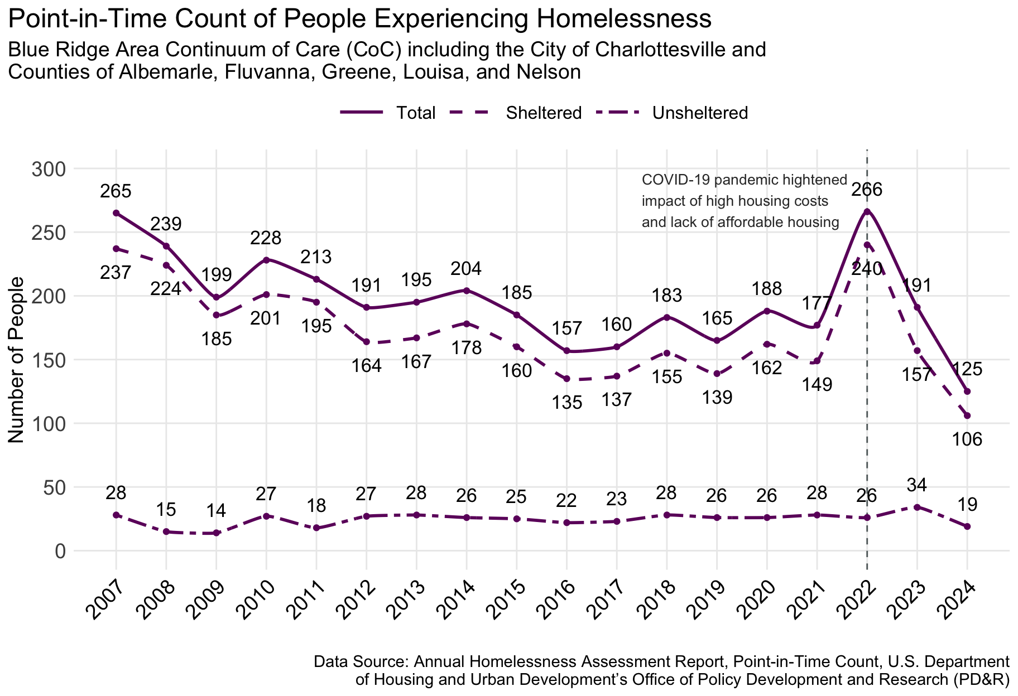

Figure 5.7: Point-in-Time Count of People Experiencing Homelessness in the Blue Ridge Area Continuum of Care (CoC) including the City of Charlottesville and Counties of Albemarle, Fluvanna, Greene, Louisa, and Nelson, 2007-2024. In 2024, the Blue Ridge Area Coalition for the Homeless (BRACH) identified 125 people experiencing homelessness in the PIT count.

The 2024 PIT count captured 125 individuals experiencing homelessness, a roughly 25% decline from the previous year. Of these, 106 were reported as sheltered with another 19 unsheltered. The PIT count for 2024 records the lowest overall number of people experiencing homelessness at any point from 2007 to 2024. A more complete understanding of the problem requires the combined knowledge of multiple housing and homeless services organizations, as demonstrated in the presentation to Charlottesville’s city council in summer of 2024.[37] In June 2024, BRACH reported 195 individuals on the “by-name” list, a record compiled by organizations serving unhoused populations.

The most basic categories in the PIT count differentiate between ‘sheltered’ and ‘unsheltered’ homelessness, but these distinctions miss a variety of other living strategies, including doubling up. Living doubled up is defined as living with others because of economic hardship or housing loss and is precarious: a change in circumstances can quickly result in unsheltered homelessness.

Homelessness is increasingly understood in terms of “cycling,” where vulnerable individuals repeatedly move into and out of stable housing.[38] For many, doubling up is one stage of this broader cycle. New approaches to estimating and understanding the prevalence of doubling up are being developed, including estimates derived from American Community Survey microdata.[39] Applying those methods to our CoC region produces an annual estimate of 1,826 people living doubled up. Additional efforts are needed to more accurately assess the scale of doubling up specifically in Charlottesville and Albemarle, and to consider targeted interventions to support individuals experiencing this vulnerable living arrangement. 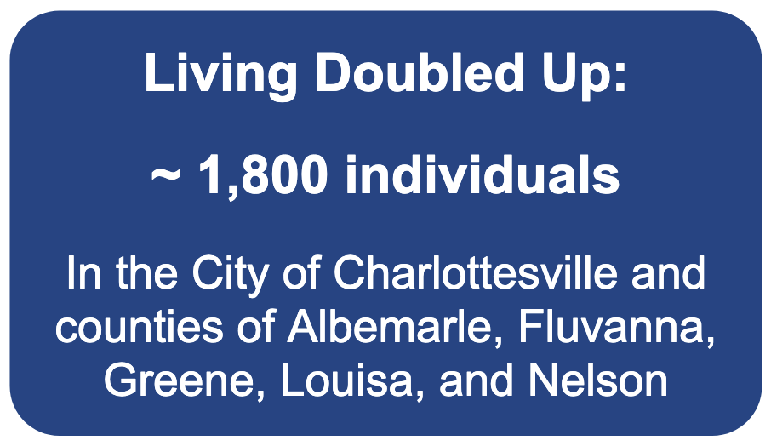

An additional source for understanding the scope of homelessness locally comes from educational data. The McKinney-Vento Act (MVA) provides federal protections and resources for the educational rights of children and youth experiencing homelessness.[40] To administer the program, state and local education agencies capture information on “children and youth who lack a fixed, regular, and adequate nighttime residence, including those who are sharing the housing of others due to loss of housing, economic hardship, or a similar reason; staying in motels, trailer parks, or camp grounds due to the lack of an adequate alternative; staying in shelters or transitional housing; or sleeping in cars, parks, abandoned buildings, substandard housing, or similar settings.”[41] As such, it captures a wider range of unhoused living arrangements than the PIT count, but only for children and youth.

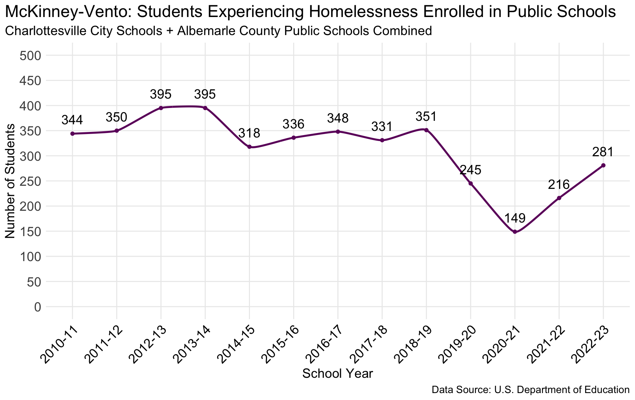

Figure 5.8: McKinney-Vento: Students Experiencing Homelessness Enrolled in Charlottesville City Schools and Albemarle County Public Schools, 2010-11 through 2022-23 school years. In the 2022-23 school year, there were 281 students identified as experiencing homelessness.

McKinney-Vento data for the combined Charlottesville City Schools and Albemarle County Public Schools captures a notably higher number of young people experiencing homelessness than what is evident in the PIT count. While the data records a decline in students experiencing homelessness in the 2019-20 and 2020-21 school years, the data for these years were impacted by the COVID-19 pandemic. The remote and hybrid learning at the onset of the pandemic reduced the ability for educational staff to recognize housing instability among their students. In the 2022-2023 school year, the most recent data available indicates the number of children in our school systems identified as homeless began trending back up to pre-pandemic levels.

### Bed Capacity Among Organizations Serving Unhoused Residents

BRACH coordinates an annual HUD-mandated count of beds provided by local homeless services organizations for people experiencing homelessness.[42] This Housing Inventory Count (HIC) captures the number of year-round beds for emergency shelter and transitional housing, seasonal beds, like those provided through PACEM during the winter months,[43] and beds associated with permanent supportive housing programs (Figure 5.9).

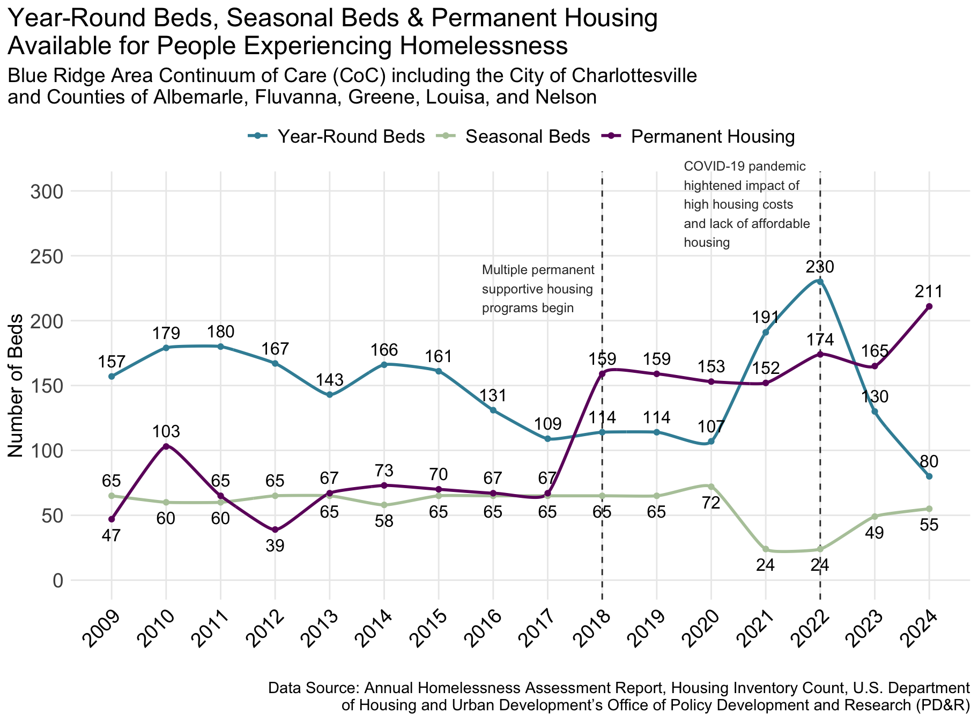

Figure 5.9: Housing Inventory Count: Year-Round, Seasonal Beds and Permanent Housing Available for People Experiencing Homelessness in the Blue Ridge Area Continuum of Care (CoC) including the City of Charlottesville and Counties of Albemarle, Fluvanna, Greene, Louisa, and Nelson, 2009-2024. In 2024, the Blue Ridge Area Coalition for the Homeless (BRACH) identified 80 year-round beds, 55 seasonal beds, and 211 permanent housing units in the annual Housing Inventory Count (HIC).

The seasonal bed capacity is provided through PACEM and has been fairly stable during this period. The decline in 2021 reflects the transition away from congregate care during the COVID-19 pandemic, given the highly contagious nature of the virus.

The availability of emergency shelter and transitional housing declined in 2016 and 2017 in response to HUD’s decision to move funds from transitional housing and toward rapid rehousing programs. In the region, the count of transitional housing beds decreased by about 30 in 2016 and again in 2017, as funding impacted the Salvation Army’s Center of Hope and other similar programs. During the pandemic in 2020 and 2021, the availability of emergency beds increased, primarily due to the decision to use the hotel at Premier Circle as a non-congregate emergency shelter and a site for supportive services.[44] The Premier Circle project was discontinued in 2023 to prepare for the conversion of the site to a new low-income and supportive housing community, in alignment with the original intent.[45]

While emergency shelter and transitional housing in the region has seen some volatility, the number of beds associated with permanent supportive housing has been increasing. The opening of The Crossings in 2012 added a stable capacity of 30 new beds in 2013, increasing to 35 in 2016. In addition, multiple programs launched or grew in 2018, though many of these new beds are targeted towards specific populations, including programs for veterans experiencing homelessness, for individuals with serious mental illness, and for people living with HIV/AIDS. In addition, since 2016, the Haven has had funding for about 25 beds through rapid rehousing programs.

## Locality Profiles

The partnership between the UVA Center for Community Partnerships, Albemarle County and the City of Charlottesville also produced two locality profiles:

* Albemarle County Community Wellbeing Profile
* Charlottesville City Community Wellbeing Profile

These reports have additional detailed information on the demographics, health, education, and living standards in each locality.

## Contributors

This report was done in partnership between the UVA Center for Community Partnerships, Albemarle County, and the City of Charlottesville. The collaborators on this report are:

* Michele Claibourn, Director of Community-Centered Analysis, Center for Community Partnerships, University of Virginia and Assistant Professor, Batten School of Leadership and Public Policy, University of Virginia
* Elizabeth Mitchell, Senior Research Specialist, Center for Community Partnerships, University of Virginia
* Henry DeMarco, Center for Community Partnerships Data Fellow
* Sherica Jones-Lewis, Director of Community Research, Center for Community Partnerships, University of Virginia
* Jess Harris, Assistant Director of Community Research, Center for Community Partnerships, University of Virginia
* Jesse Brookins, Director, Albemarle County
* Tamara Ryan, Coordinator, Albemarle County
* Ashley Marshall, Deputy City Manager for Social Equity, City of CharlottesvilleThe UVA Center for Community Partnerships

### The UVA Center for Community Partnerships

Established in 2019, the mission of the UVA Center for Community Partnerships is to build mutually beneficial partnerships in university communities by advancing a transformative approach to the fundamental research mission, which will, in turn, reform institutional values, pedagogy, and operations. We envision universities that serve local communities by bringing rich research resources to bear and equipping students to lead in building a more just society.

Community-Centered Analysis centers on community-driven partnerships to provide advocates, as well as civic and private sector leaders, with data and metrics, contextualized analysis, interactive maps and data visualizations, and narrative storytelling as a resource in pursuit of a more just region.

### Project Repository

The work supporting the Community Wellbeing Profiles, including our data collection documentation and the corresponding data, is publicly available on GitHub at https://github.com/virginiaequitycenter/regional-equity-profile/tree/main

This work is licensed under a Creative Commons Attribution 4.0 International License.

### Citation

Michele Claibourn, Elizabeth Mitchell, Henry DeMarco. “Charlottesville & Albemarle Area Community Wellbeing Profile.” Center for Community Partnerships, University of Virginia. July 2025

## Appendix

### Data Sources by Figure/Table

| Figure | Source |
| --- | --- |
| Demographic Profile | |
| Figure 1.1: White and Non-White Population Composition, 1790-2020. | U.S. Census Bureau. Race, U.S. Decennial Census 1790-2020. Prepared by Social Explorer. |
| Figure 1.2: Population Composition by Race & Ethnicity, 2013-2023. | U.S. Census Bureau. "Hispanic or Latino Origin by Race." American Community Survey, ACS 5-Year Estimates Detailed Tables, Table B03002, 2023, data.census.gov/table/ACSDT5Y2023.B03002?q=B03002&g=050XX00US51003,51540. |
| Figure 1.3: Limited & Non-Limited English Speaking Households, 2023. | U.S. Census Bureau. "Detailed Household Language by Household Limited English Speaking Status." American Community Survey, ACS 5-Year Estimates Detailed Tables, Table B16002, 2023, data.census.gov/table/ACSDT5Y2023.B16002?q=B16002&g=050XX00US51003,51540. |
| Figure 1.4: Limited & Non-Limited English Speaking Households by Language, 2023. | U.S. Census Bureau. "Detailed Household Language by Household Limited English Speaking Status." American Community Survey, ACS 5-Year Estimates Detailed Tables, Table B16002, 2023, data.census.gov/table/ACSDT5Y2023.B16002?q=B16002&g=050XX00US51003,51540. |
| Figure 1.5: Disability Status by Age Group, 2023. | U.S. Census Bureau. "Sex by Age by Disability Status." American Community Survey, ACS 5-Year Estimates Detailed Tables, Table B18101, 2023, data.census.gov/table/ACSDT5Y2023.B18101?q=B18101&g=050XX00US51003,51540. |
| Figure 1.6: Number of people identifying as having a particular disability, 2023. | U.S. Census Bureau. "Sex by Age by Hearing Difficulty." American Community Survey, ACS 5-Year Estimates Detailed Tables, Table B18102, 2023, data.census.gov/table/ACSDT5Y2023.B18102?q=B18102&g=050XX00US51003,51540.; U.S. Census Bureau. "Sex by Age by Vision Difficulty." American Community Survey, ACS 5-Year Estimates Detailed Tables, Table B18103, 2023, data.census.gov/table/ACSDT5Y2023.B18103?q=B18103&g=050XX00US51003,51540. ; U.S. Census Bureau. "Sex by Age by Cognitive Difficulty." American Community Survey, ACS 5-Year Estimates Detailed Tables, Table B18104, 2023, data.census.gov/table/ACSDT5Y2023.B18104?q=B18104&g=050XX00US51003,51540.; U.S. Census Bureau. "Sex by Age by Ambulatory Difficulty." American Community Survey, ACS 5-Year Estimates Detailed Tables, Table B18105, 2023, data.census.gov/table/ACSDT5Y2023.B18105?q=B18105&g=050XX00US51003,51540.; U.S. Census Bureau. "Sex by Age by Self-Care Difficulty." American Community Survey, ACS 5-Year Estimates Detailed Tables, Table B18106, 2023, data.census.gov/table/ACSDT5Y2023.B18106?q=B18106&g=050XX00US51003,51540. ; U.S. Census Bureau. "Sex by Age by Independent Living Difficulty." American Community Survey, ACS 5-Year Estimates Detailed Tables, Table B18107, 2023, data.census.gov/table/ACSDT5Y2023.B18107?q=B18107&g=050XX00US51003,51540. |
| AHDI | |
| Table 1: American Human Development Index: Local and State-wide Comparison | Life Expectancy: "Virginia Data and Resources." County Health Rankings, www.countyhealthrankings.org/health-data/virginia/data-and-resources. Educational Attainment: U.S. Census Bureau. "Educational Attainment." American Community Survey, ACS 5-Year Estimates Subject Tables, Table S1501, 2023, data.census.gov/table/ACSST5Y2023.S1501?q=S1501&g=050XX00US51003,51540. School Enrollment: U.S. Census Bureau. "School Enrollment." American Community Survey, ACS 5-Year Estimates Subject Tables, Table S1401, 2023, data.census.gov/table/ACSST5Y2023.S1401?q=S1401&g=050XX00US51003,51540. Median Personal Earnings: U.S. Census Bureau. "Median Earnings in the Past 12 Months (in 2023 Inflation-Adjusted Dollars) by Sex for the Population 16 Years and Over With Earnings in the Past 12 Months." American Community Survey, ACS 5-Year Estimates Detailed Tables, Table B20002, 2023, https://data.census.gov/table/ACSDT5Y2023.B20002?q=B20002&g=050XX00US51003,51540. |
| Health Profile | |
| Figure 3.1: Average Life Expectancy, 2019-2024. | "Virginia Data and Resources." County Health Rankings, www.countyhealthrankings.org/health-data/virginia/data-and-resources |
| Figure 3.2: Primary care and mental health care providers, 2016-2024. | "Virginia Data and Resources." County Health Rankings, www.countyhealthrankings.org/health-data/virginia/data-and-resources |
| Figure 3.3: Residents with No Health Insurance, 2017-2023. | U.S. Census Bureau. "Selected Characteristics of Health Insurance Coverage in the United States." American Community Survey, ACS 5-Year Estimates Subject Tables, Table S2701, 2023, data.census.gov/table/ACSST5Y2023.S2701?q=S2701&g=050XX00US51003,51540. |
| Figure 3.4: Access to Parks & Exercise Opportunities, 2020-2024. | "Virginia Data and Resources." County Health Rankings, www.countyhealthrankings.org/health-data/virginia/data-and-resources |
| Education Profile | |
| Figure 4.1: Educational Attainment in Charlottesville and Albemarle, 2018-2023. | U.S. Census Bureau. "Educational Attainment." American Community Survey, ACS 5-Year Estimates Subject Tables, Table S1501, 2023, data.census.gov/table/ACSST5Y2023.S1501?q=S1501&g=050XX00US51003,51540. |
| Figure 4.2: Educational Attainment by Race/Ethnicity for the population 25 years and over, 2023. | U.S. Census Bureau. "Educational Attainment." American Community Survey, ACS 5-Year Estimates Subject Tables, Table S1501, 2023, data.census.gov/table/ACSST5Y2023.S1501?q=S1501&g=050XX00US51003,51540. |
| Figure 4.3: School Enrollment By Age Group in Charlottesville and Albemarle, 2018-2023. | U.S. Census Bureau. "School Enrollment." American Community Survey, ACS 5-Year Estimates Subject Tables, Table S1401, 2023, data.census.gov/table/ACSST5Y2023.S1401?q=S1401&g=050XX00US51003,51540. |
| Table 2: Child Care Supply | Child Care Supply Data by Locality, Child Care Aware of Virginia. https://vachildcare.com/data-2/child-care-supply-data-by-locality/ |
| Figure 4.4: Civic Sector Membership Organizations, 2017-2024. | "Virginia Data and Resources." County Health Rankings, www.countyhealthrankings.org/health-data/virginia/data-and-resources |
| Living Standards and Housing Profile | |
| Figure 5.1: Median Personal Earnings, 2012-2023. | U.S. Census Bureau. "Sex by Earnings in the Past 12 Months (in 2023 Inflation-Adjusted Dollars) for the Population 16 Years and Over With Earnings in the Past 12 Months." American Community Survey, ACS 5-Year Estimates Detailed Tables, Table B20001, 2023, data.census.gov/table/ACSDT5Y2023.B20001?q=B20001&g=050XX00US51003,51540. |
| Figure 5.2: Median Household Income by Race/Ethnicity, 2023. | U.S. Census Bureau. "Household Income in the Past 12 Months (in 2023 Inflation-Adjusted Dollars)." American Community Survey, ACS 5-Year Estimates Detailed Tables, Table B19001A-I, 2023, data.census.gov/table/ACSDT5Y2023.B19001?q=B19001&g=050XX00US51003,51540. |
| Figure 5.3: Trends in Work and Living Locations in Charlottesville and Albemarle for 2002, 2012, 2022. | "Longitudinal Employer-Household Dynamics (LEHD) Origin-Destination Employment Statistics (LODES)," U.S Census Bureau, 2002, 2012, 2022. lehd.ces.census.gov/data/ |
| Figure 5.4: Housing Status, 2023. | U.S. Census Bureau. "Tenure." American Community Survey, ACS 5-Year Estimates Detailed Tables, Table B25003, 2023, data.census.gov/table/ACSDT5Y2023.B25003?q=B25003&g=050XX00US51003,51540. |
| Figure 5.5: Rent Burdened Households, 2023. | U.S. Census Bureau. "Gross Rent as a Percentage of Household Income in the Past 12 Months." American Community Survey, ACS 5-Year Estimates Detailed Tables, Table B25070, 2023, data.census.gov/table/ACSDT5Y2023.B25070?q=B25070&g=050XX00US51003,51540. |
| Figure 5.6: Cases Filed and Eviction Judgments within Local Court Jurisdictions, 2018-2024. | Data from Virginia's General District Courts was provided by the Civil Court Data Initiative at Legal Services Corporation. |
| Figure 5.7: Point-in-Time Count of People Experiencing Homelessness in the Blue Ridge Area Continuum of Care (CoC), 2007-2024. | "2024 AHAR: PIT Estimates of Homelessness in the US; Annual Homelessness Assessment Report," HUD Office of Policy Development and Research. www.huduser.gov/portal/datasets/ahar/2024-ahar-part-1-pit-estimates-of-homelessness-in-the-us.html |
| Figure 5.8: McKinney-Vento: Students Experiencing Homelessness Enrolled in Charlottesville City Schools and Albemarle County Public Schools, 2010-11 through 2022-23 school years. | "Program: McKinney-Vento Act," Data Express, U.S. Department of Education. eddataexpress.ed.gov/download/data-library?field_year_target_id=All&field_population_value=&field_data_topic_target_id=All&field_reporting_level_target_id=All&field_program_target_id=42&field_file_spec_target_id=All&field_data_group_id_target_id=All&combine= |
| Figure 5.9: Housing Inventory Count: Year-Round, Seasonal Beds and Permanent Housing Available for People Experiencing Homelessness in the Blue Ridge Area Continuum of Care (CoC), 2009-2024. | "2024 AHAR: PIT Estimates of Homelessness in the US; Annual Homelessness Assessment Report," HUD Office of Policy Development and Research. www.huduser.gov/portal/datasets/ahar/2024-ahar-part-1-pit-estimates-of-homelessness-in-the-us.html |

1. References to the combined region or the Charlottesville-Albemarle region indicate measures cover both the city of Charlottesville and Albemarle County. These regional measures do not include nearby adjacent localities unless explicitly noted.
2. University of Virginia Weldon Cooper Center for Public Service. (2024). Virginia Population Estimates. Retrieved from <https://coopercenter.org/virginia-population-estimates>.
3. Paul Siegel, Elizabeth Martin, and Rosalind Bruno. “Language Use and Linguistic Isolation: Historical Data and Methodological Issues.” Statistical Policy Working Paper, United States Census Bureau. <https://www.census.gov/library/working-papers/2007/adrm/ssm2007-02.html>
4. “About Human Development.” Measure of America, measureofamerica.org/human-development/
5. “Social Determinants of Health.” CDC, 15 May 2024, [www.cdc.gov/public-health-gateway/php/about/social-determinants-of-health.html](https://www.cdc.gov/public-health-gateway/php/about/social-determinants-of-health.html)
6. See the Measure of America Methodological Notes for the complete methodology: measureofamerica.org/wp-content/uploads/2010/11/The-Measure-of-America-2010-2011-Methodological-Notes.pdf
7. “MAAP2Health.” Blue Ridge Health District, 2019, www.vdh.virginia.gov/content/uploads/sites/91/2019/08/2019-MAPP2Health-Report.pdf
8. “What’s behind ‘shocking’ U.S. life expectancy decline—and what to do about it.” Harvard School of Public Health, April 13, 2023, [hsph.harvard.edu/news/whats-behind-shocking-u-s-life-expectancy-decline-and-what-to-do-about-it/](https://hsph.harvard.edu/news/whats-behind-shocking-u-s-life-expectancy-decline-and-what-to-do-about-it/)
9. “Why life expectancy in the US is falling.” Harvard Health Publishing, October 20, 2022, [www.health.harvard.edu/blog/why-life-expectancy-in-the-us-is-falling-202210202835](https://www.health.harvard.edu/blog/why-life-expectancy-in-the-us-is-falling-202210202835)
10. “US life expectancy has rebounded closer to pre-pandemic levels.” CNN Health, December 19, 2024, [www.cnn.com/2024/12/19/health/us-life-expectancy-2023/index.html](https://www.cnn.com/2024/12/19/health/us-life-expectancy-2023/index.html)
11. “Map Reveals US States With Worst Life Expectancies.” Newsweek, Aug 25, 2024, [www.newsweek.com/map-us-states-worst-life-expectancy-mortality-1943971](https://www.newsweek.com/map-us-states-worst-life-expectancy-mortality-1943971)
12. “All hands on deck needed to confront physician shortage crisis.” American Medical Association, Jun 10, 2024, [www.ama-assn.org/practice-management/sustainability/all-hands-deck-needed-confront-physician-shortage-crisis](https://www.ama-assn.org/practice-management/sustainability/all-hands-deck-needed-confront-physician-shortage-crisis)
13. Arno Cai, et al. “Trends In Mental Health Care Delivery By Psychiatrists And Nurse Practitioners In Medicare, 2011–19.” Health Affairs 2022 41:9, 1222-1230. Accessed:

    [pmc.ncbi.nlm.nih.gov/articles/PMC9769920/#:~:text=The%20shortage%20is%20projected%20to,14%2C000%E2%80%9331%2C000%20psychiatrists%20in%202024.&text=The%20deficit%20of%20mental%20health,counties%20have%20no%20practicing%20psychiatrists.](https://pmc.ncbi.nlm.nih.gov/articles/PMC9769920/#:~:text=The%20shortage%20is%20projected%20to,14%2C000%E2%80%9331%2C000%20psychiatrists%20in%202024.&text=The%20deficit%20of%20mental%20health,counties%20have%20no%20practicing%20psychiatrists.)
14. Arno Cai, et al.
15. Reinert, M, Fritze, D & Nguyen, T. (July 2024). “The State of Mental Health in America 2024.” Mental Health America, Alexandria, VA. <https://mhanational.org/the-state-of-mental-health-in-america/>
16. Lyu W, Wehby GL. Effects of Virginia’s 2019 Medicaid Expansion on Health Insurance Coverage, Access to Care, and Health Status. INQUIRY: The Journal of Health Care Organization, Provision, and Financing. 2022. doi:10.1177/00469580221092856. Accessed: [pmc.ncbi.nlm.nih.gov/articles/PMC9134455/](https://pmc.ncbi.nlm.nih.gov/articles/PMC9134455/)
17. Lyu W, Wehby GL, 2022.
18. Lyu W, Wehby GL, 2022.
19. Issue Brief No. HP-2024-12 “Health Insurance Coverage and Access to Care Among Latinos: Recent Trends and Key Challenges” Washington, DC: Office of the Assistant Secretary for Planning and Evaluation, U.S. Department of Health and Human Services. June 2024. aspe.hhs.gov/reports/health-insurance-coverage-access-care-latinos
20. “Health Insurance Coverage and Access to Care Among Latinos”
21. Foderaro L W , Klein, W, “The Power of Parks to Promote Health,” San Francisco: Trust for Public Land, 2023, [www.tpl.org/parks-promote-health-report](https://www.tpl.org/parks-promote-health-report)
22. “Access to Exercise Opportunities.” County Health Rankings, www.countyhealthrankings.org/health-data/health-factors/health-behaviors/diet-and-exercise/access-to-exercise-opportunities?year=2024
23. “Biscuit Run Park.” Albemarle County, Parks & Recreation, [www.albemarle.org/government/parks-recreation/biscuit-run-park](https://www.albemarle.org/government/parks-recreation/biscuit-run-park#ad-image-0)
24. Census Bureau data on enrollment ask about elementary school, high school, college, or professional school. Public, private & homeschool are all included. This count excludes vocational, technical or business schools such as trade schools or on the job training.
25. Child Care Aware of Virginia notes that there are groups of child care programs not captured in their totals, including: 1) home-based programs that are neither licensed nor registered, but are eligible to participate in the state Subsidy program, 2) family child care programs that serve four or fewer unrelated children and are not licensed or registered with the state in any capacity, and 3) camp programs that only operate during the summer.
26. American Community Survey 5-year estimates (2019-2023), [Table B23008](https://data.census.gov/table/ACSDT5Y2023.B23008?q=b23008&g=050XX00US51003,51540).
27. Chetty, Jackson, Kuchler, Stroebel, et al. “Social Capital and Economic Mobility: Non-Technical Research Summary,” [opportunityinsights.org/wp-content/uploads/2022/07/socialcapital_nontech.pdf](http://opportunityinsights.org/wp-content/uploads/2022/07/socialcapital_nontech.pdf). Full paper published in Nature 608, pages 108–121 (2022) doi.org/10.1038/s41586-022-04996-4
28. www.socialcapital.org/
29. Remote work helping drive wealthy families from D.C. area to Charlottesville region.” 29News, Jan. 9, 2025, [www.29news.com/2025/01/09/remote-work-helping-drive-wealthy-families-dc-area-charlottesville-region/](https://www.29news.com/2025/01/09/remote-work-helping-drive-wealthy-families-dc-area-charlottesville-region/). See also, Lombard, Hamilton. “Since the pandemic, young adults have fueled the revival of small towns and rural areas,” UVA Weldon Cooper Center for Public Service, 2024, www.coopercenter.org/research/young-adults-fuel-revival-small-towns-rural-areas
30. “Research shows far-reaching costs of eviction filings to tenants – regardless of the outcome in court.” Poverty Solutions: University of Michigan, July 16, 2024, [poverty.umich.edu/2024/07/16/research-shows-far-reaching-costs-of-eviction-filings-to-tenants-regardless-of-the-outcome-in-court/](https://poverty.umich.edu/2024/07/16/research-shows-far-reaching-costs-of-eviction-filings-to-tenants-regardless-of-the-outcome-in-court/)
31. “2024 Virginia Eviction Reduction Pilot (VERP) Awarded.” TJPDC, [tjpdc.org/newsbrief/2024-virginia-eviction-reduction-pilot-verp-awarded/](https://tjpdc.org/newsbrief/2024-virginia-eviction-reduction-pilot-verp-awarded/) and “Financial Opportunity Center.” Piedmont Housing Alliance, [piedmonthousingalliance.org/financial-opportunity-center/](https://piedmonthousingalliance.org/financial-opportunity-center/)
32. Treglia, D., Byrne, T., & Tamla Rai, V. (2023). Quantifying the Impact of Evictions and Eviction Filings on Homelessness Rates in the United States. Housing Policy Debate, 1–12. doi.org/10.1080/10511482.2023.2186749
33. Greene, S., Richardson, T., Bryon, J., & Cho, R. “Rise in homelessness averted amidst

    worsening housing needs in 2021. What does this tell us about how to end homelessness in the U.S.?” U.S. Department of Housing and Urban Development Office of Policy Development and Research, 2023, [www.huduser.gov/portal/pdredge/pdr-edge-frm-asst-sec-082223.html](https://www.huduser.gov/portal/pdredge/pdr-edge-frm-asst-sec-082223.html). Archived Access: web.archive.org/web/20250201024008/https://www.huduser.gov/portal/pdredge/pdr-edge-frm-asst-sec-082223.html
34. “What is a Continuum of Care?” National Alliance to End Homelessness, January 14, 2010, [endhomelessness.org/resource/what-is-a-continuum-of-care/](https://endhomelessness.org/resource/what-is-a-continuum-of-care/). The U.S. Department of Housing and Urban Development mandates that homeless services be administered through a CoC, with a HUD-designated lead organization that coordinates with service providers and distributes funding. “Continuum of Care Program.” U.S. Department of Housing and Urban Development, [www.hud.gov/program_offices/comm_planning/coc](https://www.hud.gov/program_offices/comm_planning/coc).
35. “VA-504 - Charlottesville CoC.” HUD Exchange, [www.hudexchange.info/grantees/va-504/](https://www.hudexchange.info/grantees/va-504/)
36. “How the HUD Point-in-Time Count Underestimates the Homelessness Crisis in America.” National Law Center on Homelessness & Poverty, [homelesslaw.org/wp-content/uploads/2018/10/HUD-PIT-report2017.pdf](https://homelesslaw.org/wp-content/uploads/2018/10/HUD-PIT-report2017.pdf)
37. O’Hare, Erin. “Local agencies shock Charlottesville City Council members with latest data on the number of folks experiencing homelessness.” Charlottesville Tomorrow, June 21, 2024, [www.cvilletomorrow.org/local-agencies-shock-city-council-members-with-latest-data-on-the-number-of-folks-experiencing-homelessness/](https://www.cvilletomorrow.org/local-agencies-shock-city-council-members-with-latest-data-on-the-number-of-folks-experiencing-homelessness/)
38. McConnaughy, Melanie. “Breaking Cycles of Homelessness: Achieving Stability.” Homelessness Policy Research Institute, 2024, [hpri.usc.edu/homeless_research/breaking-cycles-of-homelessness-achieving-stability/](https://hpri.usc.edu/homeless_research/breaking-cycles-of-homelessness-achieving-stability/)
39. Richard, Molly K., et al. 2022. “Quantifying Doubled-Up Homelessness: Presenting a New Measure Using U.S. Census Microdata.” Housing Policy Debate 34 (1): 3–24. doi:10.1080/10511482.2021.1981976.
40. “McKinney-Vento Act: Quick Reference.” School House Connection, [schoolhouseconnection.org/wp-content/uploads/2024/07/McKinney-Vento-Act-Quick-Reference-August-2024.pdf](https://schoolhouseconnection.org/wp-content/uploads/2024/07/McKinney-Vento-Act-Quick-Reference-August-2024.pdf)
41. 42 U.S.C. §11434a(2)
42. “Point-in-Time Count and Housing Inventory Count.” HUD Exchange, [www.hudexchange.info/programs/hdx/pit-hic/#2024-pit-count-and-hic-guidance](https://www.hudexchange.info/programs/hdx/pit-hic/#2024-pit-count-and-hic-guidance)
43. “About PACEM.” PACEM, [pacemshelter.org/about-pacem/](https://pacemshelter.org/about-pacem/)
44. “PACEM at Premier Circle.” PACEM, [pacemshelter.org/pacem-at-premier-circle/](https://pacemshelter.org/pacem-at-premier-circle/),<https://dailyprogress.com/news/local/business/development/crews-set-to-break-ground-on-project-aimed-at-halving-charlottesvilles-homeless-population/article_d35aa0aa-84ed-11ef-888a-fbc094a0603e.html>
45. “SupportWorks Housing breaks ground on Vista 29.” Support Works Housing, 2024, [supportworkshousing.org/news/2024/11/supportworks-housing-breaks-ground-on-vista-29/](https://supportworkshousing.org/news/2024/11/supportworks-housing-breaks-ground-on-vista-29/)